
West Virginia DAR News
National Theme: “Illuminate Our Legacy”
State Theme: “Bloom Where You Are Planted”
V
Volume 48 No. 4 October 1, 2025

Message from the State Regent
October 2025
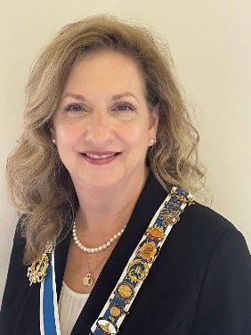
Hello Daughters,
On behalf of myself and all the State Officers, we thank you for selecting us to serve on your Executive Committee for the next three years.

The year started rapidly with our district meetings:
July 12 was the start of these meetings with the Southern District being held at
the First Baptist Church in Princeton. The Matthew French Chapter hosted a lovely
meeting with desserts served at the historic Dr. Robert B McNut house. Stella Moon,
Director; Linda Whitman, Secretary; and Debra Phillips, Treasurer
The next weekend, July 19 took us to the Bi-Centennial Inn in Buckhannon
where the Central District conducted their meeting. The Elizbeth Zane Chapter hosted
this wonderful session. Pat Goodwin, Director; Kathy Kidd, Secretary; and Linda Huggins, Treasurer
August 9 was on to Huntington in the Western District. The Buford Chapter hosted a delightful meeting at the Christ Temple Church of Huntington. Nickie Evenson, Director; Linda Keeling, Secretary; and Shelia Stevenson, Treasurer Traveling on to the Eastern District on August 16 where the Highlands of the
Potomac hosted our enjoyable meeting in Keyser at the Fountain United Brethren Church. Judy Bowyer, Director; Jerell Wright, Secretary; and Bonnie Myers, Treasurer On August 23 we went to the Northern District to meet at the Women’s Club-Lions Club Community Center in Harrisville. The Anne Royal Chapter hosted a marvelous meeting for the WV Daughters. Juia Hoffman, Director; Anna Carson; and
Annetta Siers, Treasurer Thank you to the District Officers and their Members for each successful District Meeting.
The State Information Packet (SIP) is completed and shared on the state webpage.
WVDAR|West Virginia State Society, NSDAR Thank you Mary Johnson for Chairing
this task. As you may have changes throughout the year, please reach out to Mary so
she may include any updates.
Mary is also working on the West Virginia Breakfast during Continental Congress for
2026. Please look for additional information on this event. I hope you can make it.
The Proposed State Regent’s Project was shared during the District Meetings and
can also be found on the State’s webpage: The three elements of the project are:
Education – promote “The Pledge of Allegiance through Sign Language.”
Chairs – Barby Frankenberry and Darla Treat Courtney

Patriotism – promote “Tell Her Story” Chair – Cindy Kolsun
Historic Preservation – promote “Funding of the Entrance to the International Mother’s Day Shrine.”
Chair – Pamela Bane

The State Regent’s Theme is “Bloom where you are planted.”
This was selected to honor my mother who always stressed this to myself and my siblings.
I grew up hearing this from my mom, which began with or was followed by the story of
her moving from her hometown to another town with her husband and family due to
work. At first, she didn’t want to move. But once she arrived in this new town, she
made the best of it. Getting involved in the church and community, making the most of
each opportunity.
This theme goes well with the State Regent’s Scripture of Isaiah 60:22 –
“When the time is right, I, The Lord, will make it happen.”

I joined DAR in 2013 with a newly formed chapter. As time went on and each time I was
given an opportunity, I would pray “Dear Lord, if this is where You want me to be, please.
make it happen. And if this is NOT where you want me to be, please make it happen.
And I am fine either way. “
So, I hope that for each of you, whatever you do, whatever you are involved in within.
DAR Society or within your own personal life, I wish you the best and that you too will.
BLOOM WHERE YOU ARE PLANTED.

Blessings,

Sandra Isner-Johnson, West Virginia State Regent

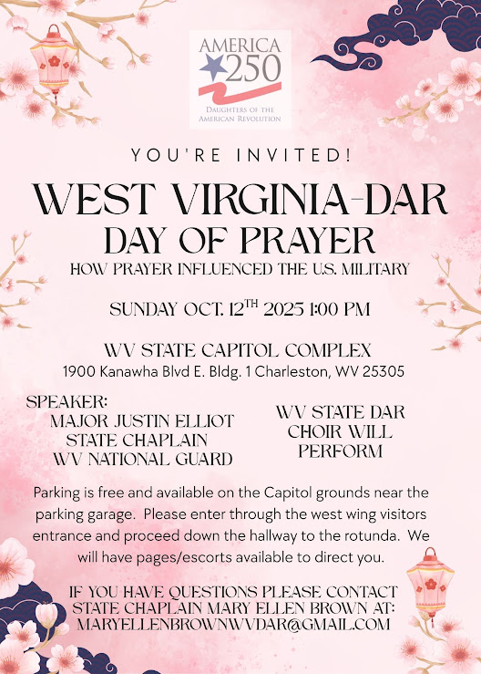
WVDAR
Stella Moon, Recording Secretary
304.482.7685
southerndistrictwvdar@hotmail.com
Subordinate Organizations
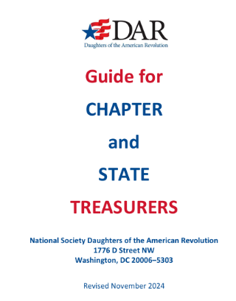
What is a subordinate organization?
If you attended a district meeting this summer, you learned that the districts are an extension of the WVDAR to conduct district business and to disseminate DAR information with State Officers and State Chairs as noted in the WVDAR Bylaws, Article XIV. The National Society does not recognize districts, only state societies and chapters. Subordinate organizations do NOT hold separate tax-exempt status with the IRS. Their financial activity must be consolidated onto the financial records of the state organization as no state-related activity should be “off the books” of the state organization. To be in compliance with the IRS, the National Society addresses this matter on page 20 in the NSDAR Guide for Chapter and State Treasurers, revised in November 2024. Each district passed the Financial Policy that states “the district will adhere to the State Subordinates section of the NSDAR Guide for Chapter and State Treasurers, revised in November 2024 by adding the WVDAR State Regent and the State Treasurer as signatories to the checking account and will provide the following documentation to the WVDAR State Treasurer Report of the Audit Review Committee.
1. Report of the Audit Review Committee.
2. FY Audit Review of Accounts
3. Copies of expense receipts that reimburse district members or third parties, except those written to the WVDAR.
4. Copies of deposits.”
To meet banking requirements, the districts passed a motion to approve the following authorized signatures on the district’s checking account – 1) district director, 2) district treasurer, 3) state regent, and 4) state treasurer.
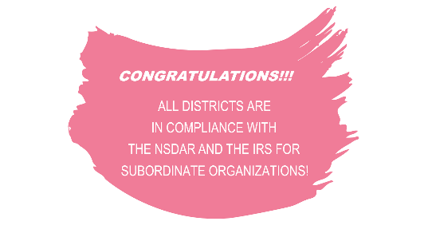
There is no loss of financial control by the districts. District finances are determined by the district. The district treasurer is responsible for paying the district’s expenses and presenting the financial statement. Four districts’ checking accounts are with TRUIST and one district’s checking account is with Union Bank.
A special thank you to Debbie Philips, Southern District Treasurer, for working with TRUIST’s Lewisburg Branch to streamline this process for the districts. CONGRATULATIONS!!! ALL DISTRICTS ARE INCOMPLIANCEWITH THENSDARANDTHEIRSFOR SUBORDINATE ORGANIZATIONS All districts approved the Financial Policy and the Authorized Signatories on their checking accounts to be in compliance with the NSDAR and the IRS.

WVDAR STATE HISTORIAN
Barbara Channell
79 Williams Crossroads Way, Fairmont WV 26554 304-816-1781 b.channell@hotmail.com
1. study and promote America history
2. commemorate historical buildings and sites
3. mark graves of Rev. War Patriots, wives, daughters and Real Daughters
4. honor outstanding achievements in historic preservation
5. promote and assist maintaining historical records
6. recognize outstanding teacher and authors of American history
Awards
OUTSTANDING TEACHER OF AMERICAN HISTORY CONTEST honors 5-12 grade full-time teachers in public, private, and parochial schools within the state. WVDAR encourages our chapters to participate in this recognition on all levels. Contact me for certificates. Submit forms for contest by Nov. 1.
THE DAR HISTORY AWARD MEDAL honors an individual or group whose study and promotion of American history on a STATE, regional, or national level.
THE NSDAR EXCELLENCE IN AMERICAN HISTORY BOOK recognizes distinguished literary works of historical non-fiction or biographies.
THE NSDAR EXCELLENCE IN AMERICAN HISTORY CHILDREN’S BOOK AWARD recognizes distinguished literary works of historical non-fiction or biographies for with children are the main audience.
MARKERS OF Rev. War Patriots, wives, daughters, and Real Daughters and historical or commemorative markers must be documented and approved by National. Chapters are asked to provide families of deceased members with information on member markers. AMERICA 25O MARKERS REVOLUTIONARY AMERICA 1775-1783” marker program is a collaboration with the William G. Pomeroy Foundation and coincides with the celebrations leading up to and during the nation’s 250th anniversary in 2026. This program focuses on commemorating points of interest significant to Revolutionary America. All DAR chapters nationwide are encouraged to apply. Chapters will contact the Office of the Historian General by email at RevolutionaryAmerica@dar.org ONLY to obtain an application specifically tailored for this program.

America 250! Committee

Malinda (Mindy) Davis – State Chair

jdavisfamily4@frontier. com

304-588-3456 (Cell) 304-659-3222 (Home)

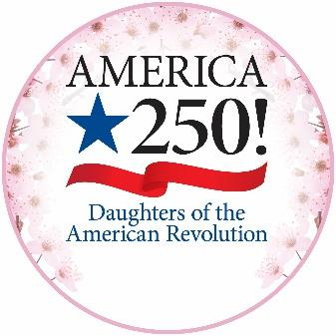
The United States stands on the eve of a grand anniversary – and DAR is

commemorating this milestone with intention. The America 250! Committee was

established to plan DAR’s involvement and maximize its visibility during our

nation’s upcoming 250th birthday in 2026. Much like the 1976 Bicentennial celebration, this observance provides an exceptional opportunity for community involvement, positive public relations and membership growth throughout DAR. NSDAR is in the external observances phase, which began in 2023 and continues to 2033, the 250th anniversary of the Treaty of Paris that ended the American Revolution.

• Chapters should seek out and welcome all prospective members.

• Encourage training of members to assist with application papers to propel membership of

all descendants of American Patriots.

• Enrich local communities through service projects and outreach by commemorating the

250th anniversary and reflecting on the values of liberty, democracy, and the sacrifices of

those who came before us.

• Bring Patriots to life through their remarkable stories and their legacies. Demonstrate

modern relevancy and diversity of experience for our Patriots.

• Recognize community members (non-DAR) with the America 250 Commendation and

Certificate for meritorious service in educating the public about the American Revolutionary War. Visit the committee webpage or the DAR Store for examples of appropriate service. The America 250! Committee offers an opportunity for every member in every chapter to participate in honoring our Patriots and increasing

membership as we Illuminate Our Legacy. The America 250! Committee has several exciting projects to promote this milestone celebration. Members are encouraged to view the committee page for complete details.

Please note the new logo available on the website.

Begin planning your chapter’s celebration of America’s Birthday!!

DAR/SAR/S.R. Relations
Daughters,
DAR places a high priority on establishing cordial and supportive relationships with our SAR and S.R. counterparts. The DAR/SAR/S.R. Relations Committee was established in 2022 to encourage such partnerships based on our shared heritage and objectives, as well as to foster support for one another through community-based events and reciprocal membership support.
There are no S.R. chapters in West Virginia, so our partners in these endeavors are members of SAR chapters located throughout the state. Chapter regents, if you have not already done so, you might consider visiting https://wvssar.org/chapters/ to find information about the 12 active chapters in our state. After making contact with an officer, become familiar with that chapter’s programs and projects. You might also consider appointing a chapter chair for the DAR/SAR/S.R. Relations Committee to keep in regular communication with your local SAR chapter.
Given that so many of our members have family members in SAR, this committee offers us an opportunity to enrich our activities through these close associations. For example, my own Bee Line Chapter has for several years invited the men of the General Adam Stephen SAR Chapter to join us in hosting a booth at the Jefferson County Fair. This work actively provides us with a venue to fundraise, to grow membership, and to share information with the public.
More detailed descriptions of this committee’s objectives can be found on the National and State websites. Visit https://www.dar.org/members/committees/service-committees/darsarsr-relations/darsarsr-relations-overview or review the committee SIP in the members section of https://wvdar.org/.
Please feel free to contact me directly if you have questions or concerns.

In DAR sisterhood,
Darla Treat Courtney
darlatreat@aol.com
304-725-1745

DAR DNA NETWORK COMMITTEE

The DAR DNA Network Committee works to educate members on the use of DNA testing for genealogy, encourage more members to test themselves and family members, and to understand how to better utilize DNA information in the application process.

NSDAR DNA Project

Members are encouraged to submit their raw DNA data to the Family Tree DNA (FTDNA) NSDAR Project. Members may submit their own DNA tests and, with permission of the tester, those of close family members. Autosomal, Y-DNA, and mitochondrial DNA test results are accepted.

The goals of the database are 1) to maintain a Y-DNA database to assist in the verification of applications where traditional documentation doesn’t exist; 2) to help preserve the genetic history of DAR members for future generations; and 3) to study the correlation of mitochondrial and autosomal DNA test results with the lineages on verified applications as a possible aid in ancestor identification.

Please assist with this historical project by joining. The more DNA collected, the better the prospects for use in future applications. You might also find unexpected DAR cousins! Whether you or your close family members have taken a test through (FTDNA) or another company, you can participate. Detailed instructions for joining can be found here.

Autosomal, (males &amp; females), Y-DNA (males only) and mitochondrial DNA (females only) test results can be uploaded. If you or your close family members have not yet tested, or you want to take a different type of DNA test, discounted tests can be purchased through FTDNA at familytreedna.com.

Chapter Chairs

Chapter Regents, please consider appointing Chapter Chairs to the DAR DNA Network Committee. I look forward to working closely with them. I would love to co-host DNA workshops, assist on DNA applications, share DNA success stories, and discuss DNA research strategies. Chairs, please contact me at hdharrison73@gmail.com and introduce yourselves. I look forward to hearing from you!

Daughters Online Community (DOC)

The Daughters Online Community is a secure, DAR-only website where Daughters may interact with one another and share resources and ideas—similar to the way we have interacted in national committee Facebook groups in the past.

There is a DAR DNA Network community on the DOC. Please join us here. Questions, ideas, concerns? Please contact Heather D. Harrison, State Chair at hdharrison73@gmail.com, or refer to the DAR DNA Network Committee page here for more

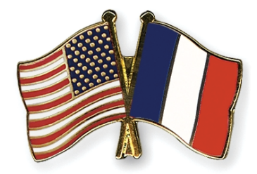
FRANCO-AMERICAN MEMORIAL COMMITTEE

The Franco-American Memorial Committee’s (FAMC) purpose is to Illuminate Our Legacy by educating, celebrating, and commemorating the long history of friendship with our oldest ally, France. During the Storage Administration, there are four FAMC areas of focus.

1) Commemorative Events with two reportable events and two categories for submissions, a category for state and a category for chapter. A FAMC Commemorative Event can focus on a person, an historic

occurrence, a site, or all three.

• Revolutionary War related Franco-American events (1775-1783).

• Events with a Franco-American theme that occurred prior to 1775 and events that occurred from 1784 to the present.

If you hold a commemorative event, submit it to your State FAMC Chair by January 31st using Form FAMC-5001. If completing Form 5001, please refer to Form FAMC 5002, the Judging Rubric, and to

Form FAMC 5000 for instructions to follow as your prepare you submission.

2) French Patriots in the American Revolutionary War

Search the List of Franco-American Patriots for possible DAR membership or to honor those listed.

Contact the FAMC National Vice Chair for Franco-American Patriots if you have any questions.

3) Franco-American Historic Sites by State

The Sites by State folders contain information about French Patriot’s gravesites, monuments, historic sites, and memorials. Le Souvenir Français will work with DAR to create new markers, refurbish existing sites, and hold commemorations.

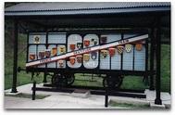
There are four sites in WV: the Statue of Lafayette in Fayetteville, the Merci Boxcar Marker in Welch (pictured here), and Hardwood near Charles Town. Articles from the Merci Boxcar are on display in the

Mansion House Museum at Tu-Endie-Wei State Park in Point Pleasant. If you visit a WV Site, please submit a Report Card on the condition of the site. Contact the FAMC Graves and Historical Site National Vice Chair if you have any questions.

4) Americans Who Fought for French Democracy in WWI and WWII

The FAMC is dedicated to honoring the past and honoring those Americans who, through word or action, contributed to the French fight for democracy.

Submit your questions about this focus to the FAMC Military History National Vice Chair.

Addition information and forms for submissions can be found on Franco-American Memorial Committee Webpage.

Visit the FAMC Community on the Daughters Online Community to see how other chapters are focusing on our Franco-American heritage.

Mickie Richardson

WV Franco-American Memorial Committee State Chair

mirichar16@gmail.com

State Regent’s Project – The Pledge of Allegiance in ASL

Daughters, we have identified an excellent YouTube video providing in-depth instruction on signing the Pledge of Allegiance using American Sign Language (ASL). As you know, Madam State Regent hopes that we can all become proficient enough to sign the Pledge during the upcoming 2026 State Conference, when we will be visited by the President General.
The video can be found online at https://www.youtube.com/watch?v=fw1p3bpXExY –“Learn How to Sign the U.S. Pledge of Allegiance in ASL.” This tool is closed captioned and provides detailed examples and definitions for all the signs/vocabulary needed. Further, the content creator has granted WVDAR permission to use the video and congratulates us for choosing to pursue this goal. Ultimately, we hope to be able to teach the Pledge to both DAR members and non-members alike. So as you work toward sharing the Pledge within your chapter and your community, please keep track of participants in this effort. We are currently developing guidance for appropriate recognitions, so please document your efforts as we move forward. You may want to consider appointing a chapter chair for this purpose.
Keep in mind that ASL training can be reported as part of your service hours and in your responses to the Chapter Master Report—for example, under Community Classroom.

Please stay turned for further information.

Best Regards,
Barby Frankenberry, Co-Chair Darla Treat Courtney, Co-Chair
bfrankenberry@aol.com darlatreat@aol.com
304-261-1696 304-725-1645

Marker at Morgan’s Grove
In her capacity as chair for the committee dedicating the America250! Marker at Morgan’s Grove,
Honorary State Regent Cheryl Brown invited then-State Historian Darla Treat Courtney to deliver
appropriate remarks for the occasion. The marker was placed as part of the 250 th anniversary
celebration honoring the Bee Line March from the Virginia frontier to Cambridge, Massachusetts.
Because of that march, Morgan’s Grove has been designated as the birthplace of the U.S. Army.
Below is a transcript of those remarks.
As I thought about my remarks here today, I realized that for me, our celebration is personal. Not
only am I a member of the Bee Line Chapter of DAR, but one of my Patriot ancestors, Pvt. William
Dollar, was an early recruit in the 2 nd Virginia Regiment.
Like the 1 st Virginia Regiment, the 2 nd Virginia was authorized in July 1775—just a few weeks after
the Bee Line March set off toward Boston. My William was a Berkeley County farmer who
volunteered from Winchester, where that other half of the Bee Line March had formed under Daniel
Morgan. William Dollar served in the Continental Army through December 1779. So, I’m satisfied
that he must have known personally and been inspired by some of those marchers.
But as my friend Cheryl Brown has reminded me, our presence here today is about more than the
Bee Line March itself. It’s also about the overall contributions of Mecklenburg, later known as
Shepherdstown, to the Revolutionary cause.
As a town of about 1,000 souls in what was then Berkeley County [Virginia], Mecklenburg saw as
many as 100 residents—fully 10 percent of the local population—march off to war. It’s likely that this
percentage accounted for most of the healthy adult males, as well as some of the youths and older
men who might have been expected to stay behind. It’s said that the town had the highest per
capita number of men under arms in the state of Virginia—and two-thirds of these would make the
ultimate sacrifice.
In addition, local residents furnished significant material aid to the war effort. Wartime records show
that they provided supplies such as beef, wheat, flour, cords of wood, horses—whatever was
needed. One resident ferried 1,100 British prisoners, 50 horses, and 15 wagon loads of baggage
across a river as they headed toward Fredericks town, likely today’s Winchester. Another was a
gunsmith who produced arms for Virginia’s troops. Other contributions, recorded or not, also
occurred. Soldiers passing through often carried off chickens and garden produce for the day’s
meal, aid that was sometimes freely given and at other times given more grudgingly.
One of Cheryl Brown’s ancestors, James Verdier, was among those who provided supplies to
support the cause. Verdier owned tanning yards serving the Mecklenburg area, and he established
the Rockland farm down off what is now Route 480 outside Shepherdstown. So, for Cheryl, this
connection means that today’s celebration is personal.
And Barby Frankenberry, here today with her granddaughter Regan, descends from 1 st Lt. William
Henshaw. Henshaw served under Capt. Hugh Stephenson during the Bee Line March and
afterwards. This means that for Barby and Regan, as for others among us, this day is truly personal.
Morgan’s Grove, where we are gathered, has a history of serving as a muster and drill ground for
soldiers and militia—not just for the American Revolution, but also for the French and Indian War
and the Civil War. But we are here today because Capt. Stephenson’s company of riflemen
assembled in this place, during the summer of 1775—just before they undertook that 24-day, 600-
mile trek to Cambridge, Massachusetts. Just before they undertook the Bee Line March. Because
of that march, history remembers Morgan’s Grove as a birthplace of the 1 st Virginia Regiment, the
Continental Army, and subsequently the United States Army.
For their part, the people of Mecklenburg supported their men at arms in the many ways that families
and communities always do during such times. They wrote letters to the front, sent tokens of
affection, reported births and deaths, looked after farms and businesses, cared for newly created
widows and orphans, and planned hasty marriages against the fear of loss and the hope for safe
return. In short, they carried on, as people will, doing whatever is necessary to survive the crisis of
war. Today, the people of Shepherdstown are still part of an intimate community, and they are
surrounded by reminders of the American Revolution. These reminders can touch their lives almost
daily—so for the people of Shepherdstown, this celebration has reason to be personal.
With this memorial, we remember the courage and sacrifices of whole communities, not just those
individuals who fought. We honor not only the Patriots of Mecklenburg and the Bee Line March, but
all those who served and contributed to the founding of this great nation. We are all truly their beneficiaries. And that legacy is and ought to be personal for each of us.

Past Curator General Barby Frankenbury, Honorary State Regent Jane Larke, and
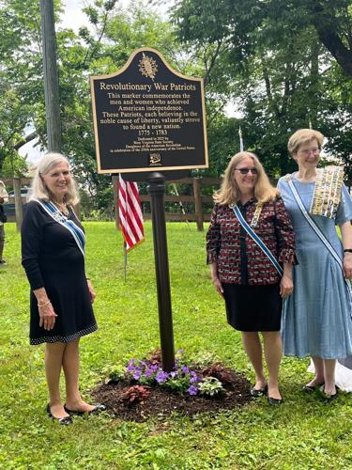
Honorary State Regent Cheryl Brown at Morgan’s Grove in Shepherdstown

Did you know that the Commemorative Events has a contest?

What a great way to show off the work you do.

See the committee page for details or contact me, Randi Gray at… dar_randi@aol.com

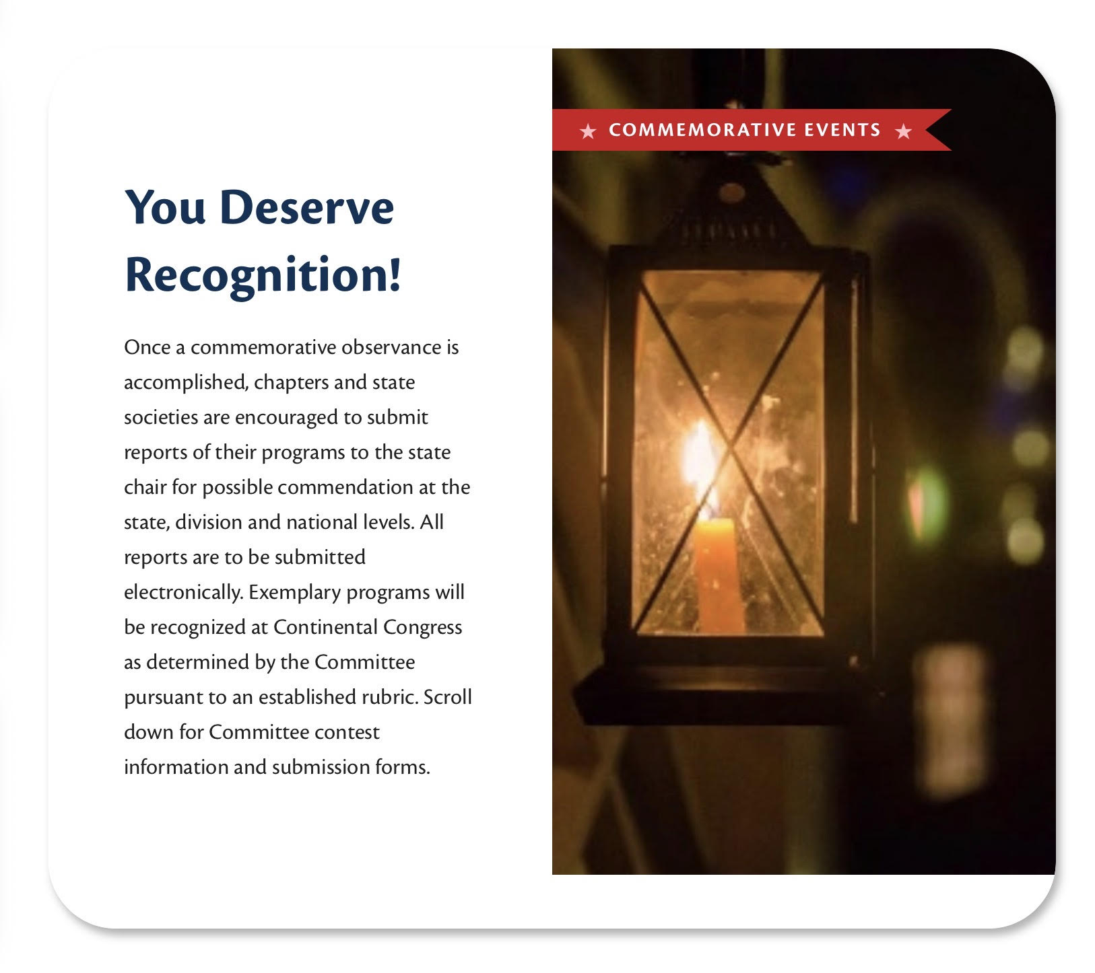

Time to Get Moving with Your Chapter!
Hello West Virginia Daughters!
The Celebrate Daughters Committee is thrilled to share some exciting statewide initiatives to
help us connect, move, and grow together. As this is a brand-new committee, Nationals are still
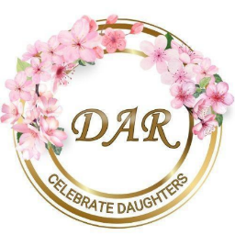
ironing out a few details—including the new fresh logo and more updates coming in
October—but the energy is already building!

October Challenge: Strength of Women Month

To kick off our statewide challenges, October will focus on physical activity and movement.
Each chapter is invited to participate by tracking how much exercise and how many steps your
members complete throughout the month.
Ladies! house work is on this spreadsheet. Cleaning can get you physical activity and helps you meet the Surgeon General’s recommendation.
● Tracking Form Available – Members can log their movement and submit it to your
chapter’s Celebrate Daughters Committee Chair.
● Deadline – Final chapter totals must be submitted to me by November 15.
● Recognition – Chapters with the highest activity and step counts will receive a
certificate at State!
● Top Movers – Please also submit the name of your chapter’s most active member. If
she’s a Junior, let me know!
We’ll hold these challenges four times a year: October, February, April, and August.
Share Your Moments
If your chapter hosts group activities or participates in any Celebrate Daughters monthly
themes, please send pictures! We’d love to showcase your efforts and celebrate your creativity.

Upcoming Monthly Themes
● November – Career Development Month
● December – National Giving Month
WV Daughters are truly amazing, and I can’t wait to see us all “Illuminate Our Legacy” in
the coming years and show the Daughters of the American Revolution that West Virginia
Daughters truly “Bloom Where You Are Planted.”

With admiration,

Stacey Adams

Celebrate Daughters Committee WV State Chair

American Heritage Committee 2025-2026
Greetings Ladies!
The American Heritage Contest details have been released, and it looks to be an extra
special one as we enter the USA’s 250th birthday! The Theme this year is The Road to
Independence – Acts of Rebellion and Treason.
‘The American Heritage Committee was established to preserve our rich and diverse
American heritage through artistic endeavors. There are numerous ways our talented
and creative Daughters can participate in the committee as we Illuminate Our Legacy.
Celebrate your art through contests in art, sculpture, crafts, fiber arts, literature &
drama, music, jewelry, and photography. The Evelyn Cole Peters Award may be
awarded at the judges discretion for excellence in any of the contest categories when
an exceptional entry is presented. West Virginia Daughters had 2024 Evelyn Cole
Peters Award winners in the Literature and Drama Category with daughters of the Bee
Line Chapter (Group Category) and Chris Painter of the Blennerhassett Chapter (Poetry
16-30 Lines) all took home first place recognition! Linda S Hall of the Anne Bailey
Chapter received a 2nd place Evelyn Cole Peters Award in Fiber Arts with a beautiful
Cross-Stitch entry.
Best of luck to all you very talented ladies! Let us keep the West Virginia talent shining.
through!

In DAR friendship,
Anna Chandler
WV State Chair, American Heritage



Units Overseas Committee

DO YOU KNOW ABOUT UNITS OVERSEAS?
DAR IS “BLOOMING ACROSS BORDERS”

The Units Overseas (UO) Committee expands our legacy globally! The UO Committee connects US and international daughters across 18 chapters in 12 countries and one US territory. Since the first overseas chapter was established in 1897, these chapters have advanced DAR’s mission of historic preservation, education and patriotism worldwide. Our State Regent, Sandra Isner- Johnson has appointed Suzanne Cronquist of the
General Andrew Lewis Chapter, as State Chair for the Storage Administration. Please contact Suzanne at secron@comcast.net if you have particular questions. Here are some highlights. There are currently about 800 DAR Members in these chapters and thousands of Associate Members. Associate membership is encouraged to support overseas projects because fundraising is often restricted or not allowed in many countries outside the United States. The Units Overseas Luncheon and Bazaar at Continental Congress is a popular annual fundraiser but more funds are needed. Some notable projects overseas have included: Restoration of graves of historic Americans who are buried in the non-Catholic cemetery in Rome by the Pax Romana Chapter. The
Bahamas Chapter supports local schools by buying uniforms and shoes for students who would not otherwise be able to enroll. The newly organized Hercules Mulligan Chapter in Ireland supports the Hearth and River Fund which raises awareness about the Missing and Murdered Indigenous Women Crisis. The Sasebo Chapter in Japan supports the Caring Package Project (Christmas gifts) for orphans and foster children at an orphanage in Tokyo. In Guam, the Mariana Islands Chapter is caretaker of a Vietnam Veterans Memorial Wall that has been restored after a 2023 typhoon. In Germany, the Palatinate Chapter provides baby blankets to new families at Ramstein military base. When asked about why to join, Suzanne remarked that a former Chapter Regent, Sandy Cowan, had encouraged her to participate as an associate member to support the Japan chapter following a natural disaster (earthquake) some years ago. What a way to reach out by DAR Daughters?! Since then, Suzanne has read Newsletters and joined Zoom meetings across a number of chapters through personal interest and vicarious travel expectations. She will attend the 100th Anniversary celebration of the founding of the
Walter Hines Page Chapter in London, England in October 2025. That was where she attended her very first (prospective member) meeting over 25 years ago! What chapters are of interest to YOU? Think of your travel interests, ancestry, and/or project support and take a look at the Units Overseas Committee webpage
http://www.dar.org/members/committees/special-committees/units-overseas/units- overseas-committee on the DAR website. You will find information on how to become an Associate Member. Dues are not unlike associate membership in the U.S. There is no charge to view the UO Daughters Abroad Newsletter online or to join the Units Overseas Community on the DOC. As DAR Daughters we can impact the world and bloom across borders!

DAR Leadership Training Committee
The DAR Leadership Training Committee is here to illuminate, educate, engage, and inspire current and future leaders of our society. The triple crown, completion of the Members, Committee Leaders, and New Horizons courses, will continue throughout
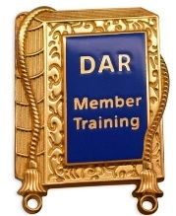
the Storage Administration. Chapter and state awards will also continue. A subscription to The American Spirit is no longer required to take the training courses. When National was looking for Daughters to serve as national chairs, national vice chairs, and division chairs during the Storage Administration, they looked at two criteria – had the member completed all three training courses and did the member have a current subscription to The American Spirit. If you aspire to move up in our Society, consider completing all three
courses.
The Members Course is a great way to learn about DAR and what it means to be a member of our Society. During the Committee Leaders Course you focus on the aspects of committee leadership and chairs learn how to become effective leaders, set goals, plan events, and work effectively with their team. Members who aspire to serve as an officer or committee chair at the chapter, state, or national level are encouraged to complete the New
Horizons Course.
If you plan to graduate from a training course and be recognized during our 2026 State Conference at the Greenbrier, all course work including projects associated with the course must be completed and submitted for review by January 24, 2026.\
Illuminate Our Legacy by expanding your knowledge and skills. Visit the DAR Leadership Committee webpage by going to the Members website at https://www.dar.org/members and selecting the Leadership Training Courses image in the center of the page. Then, select the Member Training Courses link on the left-hand side of the page.
To enroll in courses, contact Mickie Richardson @ mirichar16@gmail.com.

Mickie Richardson
WV DAR Leadership Training State Chair

E PLURIBUS UNUM COMMITTEE
State Chair Barbara Channell b.channell@hotmail.com
The mission of this new committee is to perpetuate the legacy of all the men and women who supported the cause of independence; and expanding knowledge about African American and Native American Patriots.
The mission and work of this committee is to Illuminate Our Legacy. You are encouraged to BECOME AN E PLURIBUS UNUM
Firefly: Present a Rediscovered Minute in your Chapter newsletter or at a chapter meeting Lamp: Submit a presentation on a Rediscovered Patriot to the E Pluribus Unum National Vice Chair for possible inclusion on the national committee website..
Lantern: Complete a local community presentation on Rediscovered Patriots.
Torch: Identify a new Patriot who is African American or Native American. Share your findings at epu@dar.org
Glowstick: As a chapter, you can adopt a Rediscovered Patriot.
*Have fun learning more about their life and times. * Were they from your area or somehow related to your chapter? *Chronicle your growing information about your adopted Rediscovered Patriot in your chapter meetings, book club discussions, and newsletters. * Share your discoveries on the E Pluribus Unum DOC page. : Create a doll and take it with you when offering tutoring? * Take your Rediscovered Patriot with you when walking in your local parade. *Raffle it to support Voices for your fundraising efforts! Registrar: Participate in genealogy training on hard-to-prove Patriots

Rediscovered Patriots Creative Writing Initiative DAR
For students in 9,10,11,12 Grades
“Select a figure from the Patriots of Color Database which can be accessed here. https://services.dar.org/Public/DAR_Research/search_poc/?Tab_ID=14&Tab_ID_Sub=8&Action= search Use at least two additional resources listed on this page to develop your creative writing paper to provide additional contextual information.
Discuss how he, or she, influenced the course of the American Revolution, who he or she was, and his/her contribution to the founding of a new nation, regardless of how large or small the role may have been. Based on commonly found information about life during the colonial period, develop a conversation you might have with the Patriot about being brought to light during our nation’s 250th anniversary. The title of the 500-word essay should be “Shining a Light on (the name of the Patriot).” Chapters promote the creative writing initiative to schools, libraries, and community organizations to help celebrate America’s 250th anniversary! Chapter chairs coordinate a review of essays and will provide a report to the state chair. Chapter chairs provide certificates to students who participate. I will be collaborating with chapter chairs to create a display showcasing sample essays at state meetings.

Service to America Committee
Teresa Smith, WVDAR State Chair Teresasmith1965@gmail.com

A goal of the Storage Administration is to encourage and support projects and service opportunities for every chapter to highlight historic preservation, education, and patriotism in unique, local, and impactful ways. Our goal is to log 17.76 million Service to America Hours into the Service to America online tally. We need your help to exceed our goal!

NSDAR Annual Service to America Project
This year, Daughters are asked to support Service by reaching out and thanking our First responders as the 25th Anniversary of 9/11 is September 2026. Log the number of hours in the online tally.

West Virginia State Society Service to America Project
One of the goals of the Isner-Johnson administration is to promote American Sign Language (ASL) by actively volunteering and providing resources in West Virginia.

DAR National Day of Service
Service in Seconds To honor the anniversary of DAR’s founding on October 11th, Chapters and individuals are encouraged to engage in meaningful service projects in their communities each year on or around October 11th.
Service in Seconds
Chapters and States are encouraged to plan meaningful service projects throughout the year. Service in Seconds demonstrates how Daughters can make big impacts in their communities with just seconds of work. Consider planning a Service in Seconds project as a chapter program or as an activity at a state meeting or conference. For project ideas visit the Service to America committee page.
DAR Salute to Service

The Storage Administration is continuing our nationwide “Salute to Service” outreach campaign to recognize veterans and active-duty military.

Cameo Club
West Virginia Daughters of the American Revolution’s Cameo Club members and guests, led by the Club President Charla Nutter McNaboe, celebrated the 30th Anniversary of the Club at the Robinson Grand Performing Arts Center in downtown Clarksburg Friday,
Many members “strutted their stuff,” as they donned their celebratory hats. President Nutter-McNaboe presented awards: “Best Use of DAR Blue” – Mary Ellen Brown, “Best Use of Cameos” – Barby Frankenberry, and “Most Unusual Hat” – Barbara Channell. Congratulations, ladies!!
Members enjoyed a lovely luncheon meeting and anniversary cake.
Members elected the 2025-2028 Cameo Club Officers, whom State Regent Jane Larke installed. The 2025-2028 Officers are: President, Pat Goodwin; Vice President, Mary Johnson; Secretary, Nancy Kornegay; Treasurer, Margie Ways; Registrar, Grace Arthur, and Historian, Barby Frankenberry.
The Cameo Club will meet at The GREENBRIER. Please plan to join us! All are welcome!
If you have any questions, please contact Pat Goodwin at pmg48dar@gmail.com or call her at 304-517-8592.
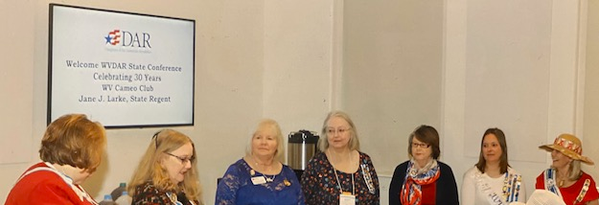

Literacy Promotion Committee
Let’s talk about something close to our hearts: literacy. It’s the key to unlocking personal
growth and building stronger communities. DAR is focused on boosting literacy, and we
need YOU to help make it happen! Here’s how you can make a difference, plus ways to
give a shout-out to those doing amazing work.
How You Can Promote Literacy
1. Pick a Literacy Leader: Get someone to lead the charge as your chapter’s
Literacy Promotion Committee Chair to keep things organized and impactful.
2. Start or Support Literacy Projects: Think reading workshops, book drives, or
tutoring sessions for kids and adults—anything that sparks a love for learning!
3. Throw Literacy Events: Host or join community events to shine a spotlight on
literacy and get people excited.
4. Team Up: Partner with local libraries, schools, or nonprofits to make your literacy
efforts even bigger and better.
5. Get a Proclamation: Push for November 1st to be recognized as Family Literacy
Day in your community to spread the word.
6. Give a Local Literacy Champion Award: Know someone (DAR member or not)
who’s working to promote literacy? Honor them with a certificate—no need to
check with national!
Shining a Light on Awesome Work
Did you know there’s a National Outstanding Service Contest? This is your chance to
celebrate DAR members or chapters doing incredible things for literacy. Send your
entries to the state chair, Jane Larke, by January 5, 2026, via email. Check out the
details and forms at WVDAR.ORG/MEMBERS under SIP. We’re looking for:

• Awesome partnerships that make literacy programs stronger.
• Cool projects that get young readers pumped.
• Efforts that show off DAR’s big commitment to literacy.

Want to recognize someone locally? There’s also a Local Literacy Champion Award.
Chapters can give this award to anyone—DAR or not—who’s making a big impact on
literacy. No national approval needed!
Let’s come together to inspire readers and create a brighter future, one story at a time.

Literacy, Libraries, and Friends Book Club

Dear Book Club Members,
We’re thrilled to announce the launch of the Literacy, Libraries, and Friends Booth Club, with an enthusiastic 65 members signed up! Your passion for reading and learning is truly inspiring, and we can’t wait to embark on this literary journey together.
Our first book selection is “Revolutionary Mothers: Women in the Struggle for America’s Independence*” by Carol Berkin. This compelling read explores the vital roles women played during the American Revolution, and we’re looking forward to hearing your
thoughts and insights during our discussion.
Mark your calendars! The book discussion will take place via Zoom on October 20 at
7:00 PM. We’ll share the Zoom link closer to the date, so stay tuned.
This book club is proudly sponsored by the WVDAR Committees of Literacy Promotion
and DAR Library Outreach, dedicated to fostering a love of reading and historical
exploration.
Happy reading, and we can’t wait to hear your opinions at our first meeting!

Warm regards,
The Literacy, Libraries, and Friends Book Club Team

The WV Patriots Records Project
Are you able to read Script or have time on your hands?
Then this is the Committee you need to be a part of…. We transcribe documents from
organizations that come to the DAR for assistance.
Please join us for the informational meeting
https://us06web.zoom.us/meeting/register/cgIpb82OTtGSQaapLsw3OA
Looking to see you there
WV DAR State Chair Karen Seguin Barton

WVCAR
Informational Meeting
October 16, 2025 7:00 pm
https://us05web.zoom.us/meeting/register/VAWq4zLeRJqaWn_IUbBnKQ
Come learn about the WV Children of the American Revolution
See about open Societies and how you can take part
The National Project is Revolutionary Valor
This year, the National Project will support the Dr. Joseph Warren Foundation (DJWF).
The DJWF is a 501 (c)(3) organization dedicated to honoring and celebrating the legacy
of ‘America’s Founding Martyr’, Dr. Joseph Warren. Funds raised from the National
Project will go to support the creation of a Dr. Joseph Warren Documentary film,
highlighting and honoring his sacrifices and contributions during the beginning of the
American Revolutionary War.
The WV State Project is Lady Washington
The WV State President Karsen Wright will be joining us to discuss her project and how
you help out
Looking to see everyone at the meeting
WV DAR CAR Chair Jerell Wright
WV CAR Sr State President Karen Barton

VAVS – Martinsburg
NSDAR’s appointments to serve as the Veterans Affairs Voluntary Services (VAVS)
representative and deputies for the VA Medical Center in Martinsburg are Darla Treat Courtney
(Representative, Bee Line Chapter), Marilyn Bremilst (Deputy, Bee Line Chapter), and Susan
Sprague (Deputy, Catherine Parker Foreman Chapter). For chapters in the Eastern District,
these Daughters are your link to the Martinsburg facility and its volunteer programs. Please feel
free to contact them if you need information or have questions.
All three new appointees attended the Martinsburg facility’s September VAVS Committee
meeting, where they were introduced by the Chief of the VA Center for Development &amp; Civic
Engagement. The briefing included updates on recent and current projects, including facility
improvements and a financial summary. Of particular note for DAR was a review of the annual
volunteer awards luncheon, the 2025 Veteran Moms Baby Shower, and details related to the
food pantry. Two of our Eastern District chapters made significant donations to the baby
shower.
The food pantry is an ongoing program overseen by the staff nutritionist. VAMC Martinsburg
maintains its own pantry and also serves as a hub for distributing food to the VA clinics in its
catchment area. Donations of shelf-stable foods are always welcome, please preview your
items to make sure the “use-by” dates are current. The program requests that, where possible,
preference should be given to low sodium, low sugar, and whole grain food choices. Donations
can be delivered directly to Volunteer Services Office at the VA Medical Center in Martinsburg.
Please call ahead for arrangements. The general hospital number is 304-263-0811. Ask for the
Volunteer Services Office.
Our next meeting is scheduled for early November.
Yours in service,
Darla Treat Courtney, darlatreat@aol.com
Marilyn Bremilst, mbremilst@icloud.com
Susan Sprague, sms26711@yahoo.com

WVDAR BLANCHE L. REYMANN SCHOLARSHIP AWARDED
The 2025-26 Blanche L. Reymann State Scholarship was awarded to Mackenzie Lyons from
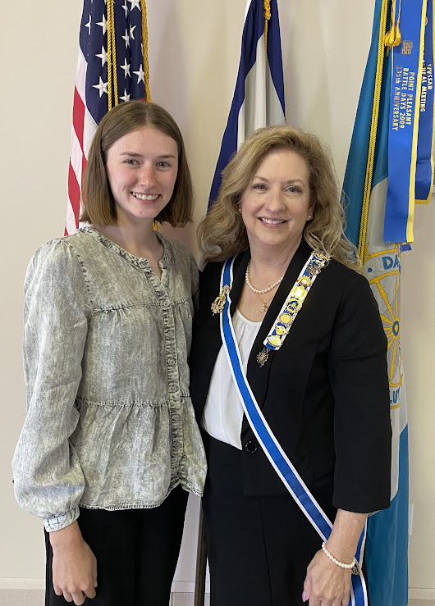
Davis & Elkins College.
The scholarship was presented to Ms. Lyons at the Western District Meeting on August 16, 2025, at the Fountain United Brethren Church in Keyser, West Virginia. The scholarship is named for Blanche L. Reymann, the State Regent of the West Virginia
Daughters of the American Revolution from 1931-1933. Following her death in 1964, the
scholarship was established in her memory to honor her commitment to education in West
Virginia. In 1967 the State Society adopted the scholarship as the Blanche L. Reymann State
Scholarship. The scholarship has been awarded annually for 57 years.
Mackenzie Lyons is the granddaughter of Dawn and John McVicker from Davis and a graduate of Tucker County High School. She is a senior at Davis & Elkins College majoring in Special
Education and Art. She is a Dean’s List and President’s List honoree, a member of Delta Alpha
Pi International Honor Society, the National Society for Leadership and Success, and Phi Omega
Mu Sorority, a past President of the Art Club, and a PATH mentor for the last 3 years. Following
graduation, Ms. Lyons hopes to work in Tucker County as a teacher.
At the Northern District Meeting, held in Harrisonville on August 23, 2025, the Northern District
Daughters voted to contribute $100 each year from the DARlings Auction to the Blanche
Reymann Scholarship Fund. Honorary State Regent, Ginger Nalley, challenged each chapter in
the Northern District to contribute $50 to the Scholarship Fund over the next year. Perhaps,
other chapters would be willing to take one this challenge,

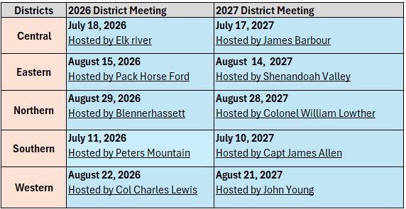

Central District Director
WVDAR Central District held the 78th Annual Meeting at the Bicentennial Inn in
Buckhannon on Saturday, July 19. The Elizabeth Zane Chapter, led by Regent Christine Mundy, and its members hosted the meeting. Central District Director Patricia “Pat” Goodwin presided during the meeting. Central District Officers are Secretary Kathy Kidd and Treasurer Linda Huggins.
Two records were set: attendance of 85 members and guests, and Darling’s proceeds
totaled $1,135.00.
Members approved an America 250 project of creating a “Central District 1776 Legacy
Scholarship” to be awarded to a graduating high school senior in the Central District in 2026.
The WVDAR Central District Legacy Scholarship is a one-time award to honor the 250th
anniversary of the United States of America, aligning with the national celebration of the
Continental Congress’s establishment of the United States on July 4, 1776. The scholarship
reflects the President General’s administration theme, “Illuminating Our Legacy,” by celebrating the enduring spirit of patriotism, education, and community service that has shaped our nation since its founding in 1776. Central District Daughters agree this scholarship underscores the DAR’s commitment to fostering education and preserving the legacy of those who fought for and built the United States, encouraging the recipient to carry forward the values of liberty, service, and progress.
The favor, a 3D replica of the Liberty Bell, highlighted the meetings theme. Elizabeth
Zane, member, Tracy Fitzwater, and her HODAR created an excellent example of patriotic
symbols.
Special guest, WVDAR State Regent Sandra Isner-Johnson, provided updates on the
134th NSDAR Continental Congress and explained her Motto, Theme, and Projects. Later, Mary Johnson, Vice Regent, and the State Regent presented Award certificates to Central District chapters and members being recognized by National and East Central Division Chairs. State Officers and State Chairs relayed pertinent information regarding their office or committee.

Jane Larke (on right) installed the 2025-2028 Central District Officers:
l-r: Linda Huggins, Treasurer; Kathy Kidd, Secretary,
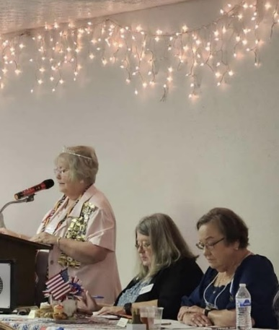
and Director, Pat Goodwin.

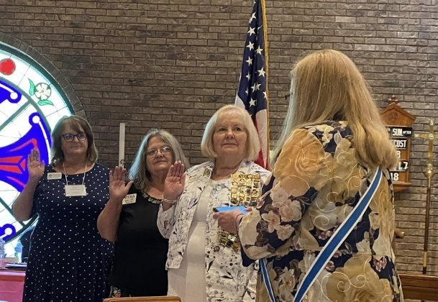
Pat Goodwin, Kathy Kidd
& Chris Mundy

Exciting News:
Central District Launches WVDAR Central District 1776 Legacy Scholarship

We're thrilled to announce the WVDAR Central District 1776 Legacy Scholarship, a project approved at the 2025 Central District meeting. This one-time $1,776 award honors the 250th anniversary of the United States in 2026, echoing the national "America 250" celebration and DAR President General's theme, "Illuminating Our Legacy."

Aligning with one of DAR's core goals to promote education, it will empower a graduating high school senior from Central District counties (Barbour, Braxton, Harrison, Lewis, Marion, Monongalia, Preston, Randolph, Roane, Tucker, Upshur) to pursue higher education, vocational training, or trade programs while embracing patriotism and service. Information has already been distributed to schools in the area.

By providing this scholarship, we're leaving our own legacy to better the future, fostering leaders who will carry forward the values of liberty and progress. We hope to award the scholarship to the selected recipient at next year's District meeting.

Blackwater Chapter
Blackwater Chapter members were hard at work again this year with their involvement with the North Central WV Honor Flight for area veterans which took place during September 12 - 14. (The trip was a three-day charter bus trip this year.) Chapter members wrote cards with personal notes of appreciation for each of the veterans. In each card was placed a special "Challenge Coin" to thank each veteran for his service to our country. Items which were purchased for the veterans' backpacks included a travel-size first aid kit and a small bottle of hand sanitizer, a small pack of tissues on which was printed inspirational thoughts, a mini box of Tic Tacs, and a travel-size deodorant.

Regent Cathy Hebb and Treasurer Marlayne Nestor spent several Tuesday afternoons volunteering at the VFW in Clarksburg helping with preparations for the Honor Flight by doing menial but important tasks such as addressing several dozen envelopes containing requests for donations, organizing and filing veterans' applications and medical forms, placing donated items in backpacks, making name tags for both veterans and guardians, and compiling dozens of hand-written notes, letters, and drawings in the veterans' mail bags.

Cathy attended both the Friday morning send-off and the Sunday afternoon "Welcome Home" for the 14 veterans and their guardians. During the breakfast Friday morning, Cathy had the opportunity to speak with the oldest veteran: Edward "Joe" Nutter, a 95-year-old Korean War Air Force veteran from Bristol, WV and hear him tell some stories about his time during the war. As he told her about himself, Joe mentioned that he lived in the Buffalo, NY area earlier in his life. That conversation lasted quite awhile, as Cathy, herself, is also from the Buffalo area. Joe's grandson, who was a recent college graduate, was Joe's guardian. He said he was "very honored and excited to be accompanying his grandfather on this memorable trip!"

Dozens of friends and family members cheered and waved American flags outside the VFW in Clarksburg as they greeted the bus as it arrived home Sunday afternoon. All of the veterans, as well as their guardians, said this was a "once in a lifetime" trip to Washington DC where they visited each of the war memorials. Many of them found the names of their comrades on the memorials they viewed. They all went home that day with enough memories to last them the rest of their days!
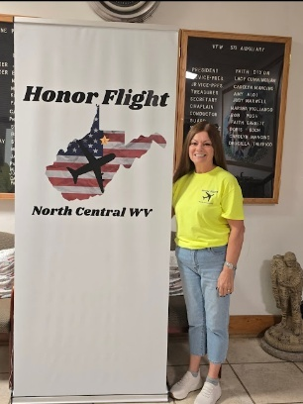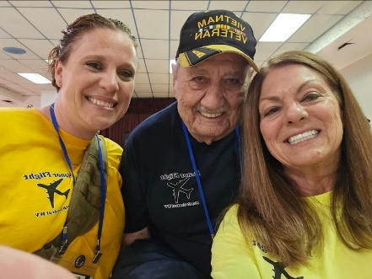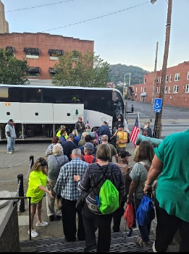

Elizabeth Zane Chapter
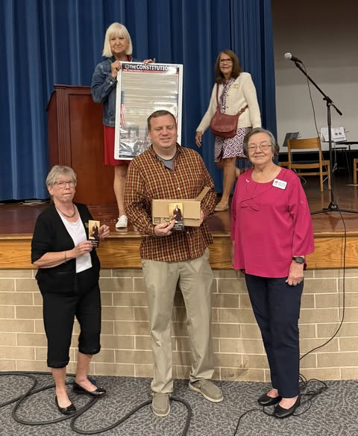
Elizabeth Zane Chapter honored Constitution Week by presenting pocket sized Constitution booklets and Preamble cards to approximately 100 students at BUHS. Marilyn Walton, Constitution Committee Chair, presented a brief history of the Constitution. Christine Mundy, Regent, read the Proclamation which had been signed by Principal Woofter and student representatives Dalton Tenney and Alex Sappey.
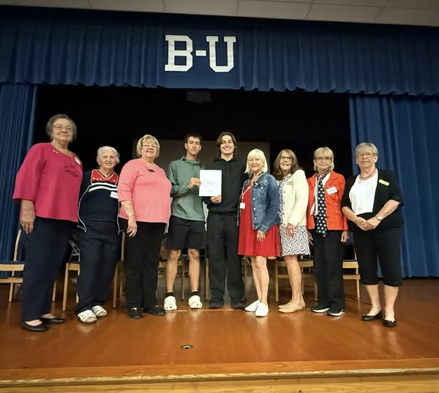

Elizabeth Zane Chapter attended Upshur County Commission meeting where the Commission signed a proclamation dedicating September 17-23 Constitution Week, Marilyn Walton, Constitution Committee Chair, gave a brief presentation.
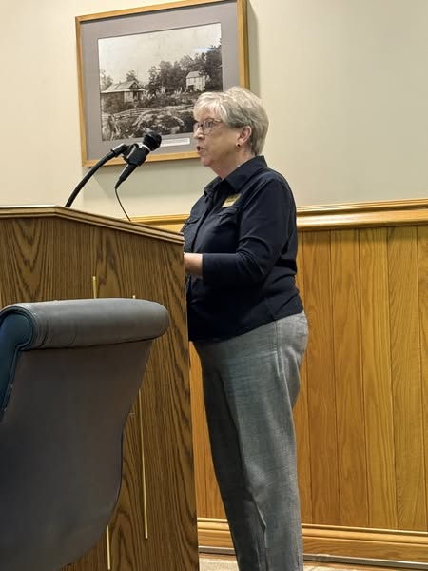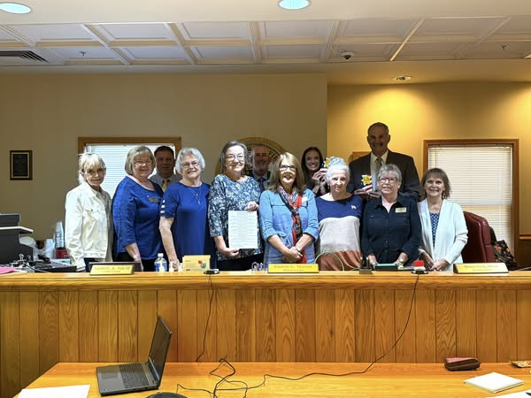
Priscilla McMurray, Eileen Johnston, Rhett Dusenbury, Brenda Casto, Chris Mundy ,
Sam Nolte, Rita Cochran, Kristi Tenney, Jackie Dinklocker, Doug Bush, Marilyn Walton,
and Carol Smith

Elizabeth Zane Chapter members attended Buckhannon City Council Meeting to accept the Constitution Week Proclamation signed by Mayor Robbie Skinner and presented by Randy Sanders. Attending were Jerilyn Alderman, Christine Mundy, Marilyn Walton, Rita Cochran and Denise Hedrick.
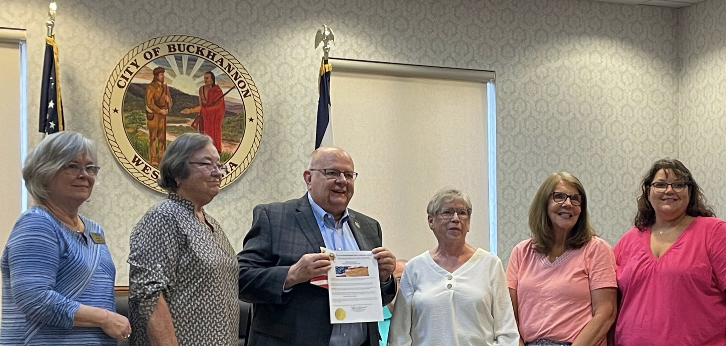

On Saturday, Sept 13 Elizabeth Zane Chapter members volunteered to help serve lunch at the American Legion's annual beans and cornbread event.
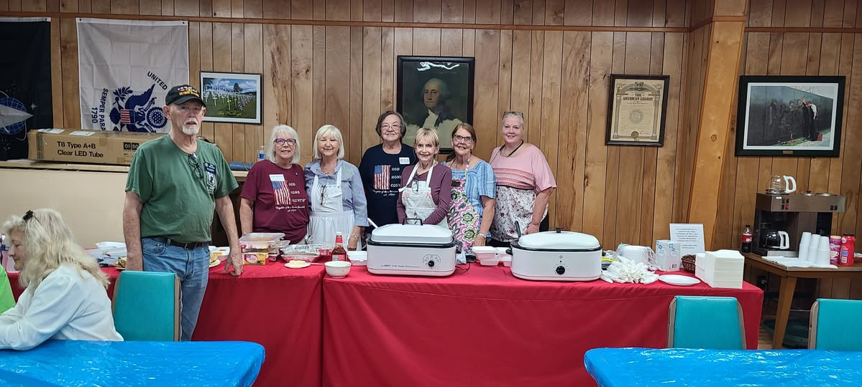
Commander Mike Wallace, Jeannie Hawkins, Linda Shomo, Chris Mundy, Priscilla Mullins, Rita Cochran and Dawn Mugrage
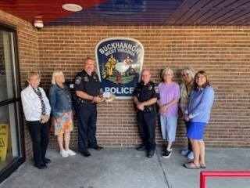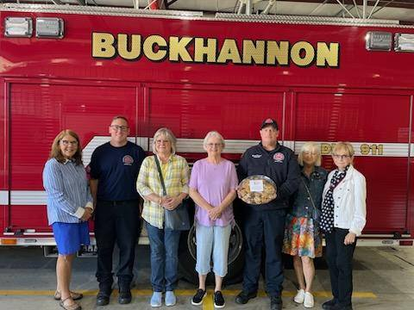
Several Elizabeth Zane Chapter members baked cookies to be delivered on Patriot Day, 9/11, to Buckhannon First Responders.

Eastern District

Bee Line Chapter
Bee Line Celebrates a Summer of Sisterhood and Service
Bee Line Chapter in Charles Town participated in several activities over the summer months, allowing us to celebrate our local history, to honor our veterans, and to take part in community activities.
Veterans Remembrance Service. Bee Line Daughters began the summer season by lending their support to the semiannual memorial service for deceased veterans at the Veterans Affairs Medical Center (VAMC) in Martinsburg. This moving program honors each veteran, who is named during a roll call, and includes Bell Honors and the sounding of Taps. This is a longstanding commitment by the chapter, which (except during the Covid lockdown) extends back for at least 15 years. As a chapter, Bee Line provided onsite refreshments and offered take-away food bags for the families attending the service. Seven members also served as hostesses: Marilyn Bremilst, Sharon Carrigan, Ann Ebersole, Linda Malczewski, Mary Supplee, Darla Treat Courtney, and Heidi Ware. Three of these Daughters—Bremilst, Malczewski, and Supplee—are also veterans.

Veterans Dinner. On June 3, three Bee Line members attended a dinner to honor local veterans. This annual event is managed by past DAR Curator General Barbara “Barby” Frankenberry and generously supported by the Shenandoah Valley Chapter. Bee Line Daughter Marilyn Bremilst, an Air Force veteran, attended with her daughter Heidi Rivard. Member Linda Coyle Myers-Hart attended with her husband Dan, an Army veteran, and Darla Treat Courtney attended with her husband Duke, an Air Force veteran.

Bee Line March Events. Beginning in late May, Bee Line Daughters participated in several activities related to America250! Celebrations related to the Bee Line March. In the summer of 1775, that march saw a company of Virginia frontier riflemen meet at Morgan’s Grove in Mecklenburg, Virginia (now Shepherdstown, West Virginia), then march for 24 days and 600 miles to join forces with General Washington at Cambridge, Massachusetts. Simultaneously, a second company set out from Winchester. The march by these two companies is now recognized as the event that marked the birth of the Continental Army and subsequently the United States Army.

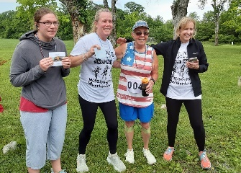
To honor the march, Bee Line Daughters held our first 5K Walk/Run on May 30. Organized by member Stacy Lindberg, each participant received an event T-shirt that featured original artwork by member Meg Davenport. The top three walkers were Marilyn Bremilst, Thomas Royston, and Patricia Toffling. The top runners were Bee Line Daughters Fran Capponi, with a time of 31.07, and her mother, Ross Watts, with a time of 32.33.

Mother-daughter runners Fran Capponi
and Ross Watts place first and second at the
2025 Bee Line Walk/Run, while Marilyn Bremilst takes honors as a walker. Organizer Stacy Lindberg presents the awards.

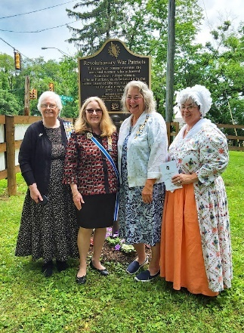
On June 7, Bee Line Daughters Amy Johnston Stottlemyer, Darla Treat Courtney, and Heidi Ware took part in the dedication ceremony for a DAR America250! marker at Morgan’s Grove. Treat Courtney, in her role as the then-state historian for West Virginia DAR, delivered remarks related to the historical and human significance of the Bee Line March. This event was sponsored by the West Virginia Society of DAR, with then-State Regent Jane Larke presiding.

Standing in front of a DAR America 250 marker, three Bee Line Daughters join then-State Regent Jane Larke to participate in a ceremony honoring the Bee Line March at Morgan’s Grove in Shepherdstown: (left to right) Darla Treat Courtney, Jane Larke, Heidi Ware, and Amy Stottlemyer.

On June 14, several Bee Line members attended a wreath laying ceremony honoring the Bee Line March at Elmwood Cemetery. Chapter Regent Heidi Ware laid a memorial wreath and members Amy Stottlemyer and Darla Treat Courtney appeared in colonial dress, representing all those women who watched their fathers, brothers, husbands, and sons march off to establish a new nation while they themselves worked to preserve the home front.

On June 21, Daughters Dee Johnson and Amy Stottlemyer attended a 250th anniversary event sponsored by the Organization of the Maryland Rifle Companies in nearby Frederick, Maryland. Dressed in colonial attire, they supported participation by the color guard unit representing the General Adam Stephen Chapter SAR. The event honored two Maryland rifle companies that headed north in the wake of the Bee Line March.

Continental Congress. During the last week of June, four Bee Line members joined Daughters from across the nation to celebrate DAR during Continental Congress. Dee Johnson, Lynn Stanley, Darla Treat Courtney, and Heidi Ware attended the West Virginia Breakfast at the Army Navy Club and the Patriotism Luncheon hosted by the DAR Project Patriot and Flag of the United States Committees. Treat Courtney and Ware also attended National Defense Night ceremonies, where West Virginia resident Ronald Wroblewski was honored with the National Outstanding Veteran Volunteer Award. Johnson attended events throughout Congress, including the memorial service for deceased members and the swearing-in ceremony for national and state officers who will serve during the next 3 years.

Bee Line Family Picnic. On July 12, about 50 Bee Line Daughters, family members, and friends gathered for a summer picnic. Those in attendance traveled from as far away as Arkansas and New Mexico. The chapter used the occasion to welcome new members with gift bags containing a “Welcome Friends” ornament, as well as useful information about our chapter and our community. New members in attendance were Evelyn Abbess, Sharon Bias, Fawn Fleagle, Alice Newton, and Stephanie Poe, as well as transferred member Linda Malczewski. In addition, length of membership certificates were presented to several members, and our new slate of officers was sworn in: Regent, Heidi Ware; First Vice-Regent, Mary Werner; Second Vice-Regent, Jean Slonaker, Chaplain, Linda Malczewski; Recording Secretary, Evie Abbess; Corresponding Secretary, Doris Bauer; Treasurer, Mary Miller; Registrar, Lynn Stanley; Historian, Stephanie Poe; and Librarian, Darla Treat Courtney.

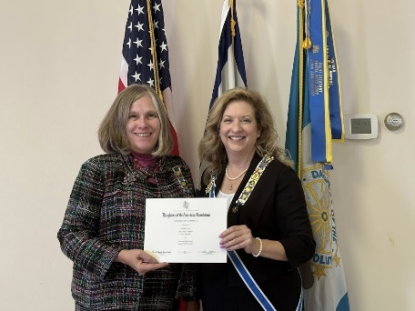
Chapter Chaplain Linda Malczewski accepts Bee Line awards at the Eastern District Meeting.

District Meeting. Several of our members attended the Eastern District Meeting in Keyser on August 16. Hosted by Highlands of the Potomac Chapter with Liber-Tea as the theme, it was an opportunity to learn about our new State Regent’s projects and, of course, to receive awards—as well as to enhance our ties with Daughters from across the District. During the awards ceremony, Bee Line received 26 Division and National certificates from 13 committees, plus the first place award for our state press book. Our five National awards were as follows: Outstanding American History Programs award, from the American History Committee; Service Above and Beyond award for Support of DAR Scholarships, from the DAR Scholarships Committee; Third Place award for our program on Bernardo de Galvez, from the Commemorative Events Committee; and two Third Place awards for Outstanding Service by a chapter, from the Literacy Promotion Committee.
Jefferson County Fair. Throughout the third week of August, Bee Line Daughters continued their tradition of participating in the Jefferson County Fair. Sharing a booth with the men of the General Adam Stephan Chapter of SAR, we focused on honoring America 250. We provided educational handouts related to the Revolution and offered such giveaways as West Virginia flag pins; red, white, and blue ballpoint pens paired with information on the flag; and bookmarks with the Preamble of the Constitution. Our signup sheet for those interested in learning more about DAR garnered over 30 new contacts—some of whom also expressed interest in SAR for their husband and C.A.R. for their children.
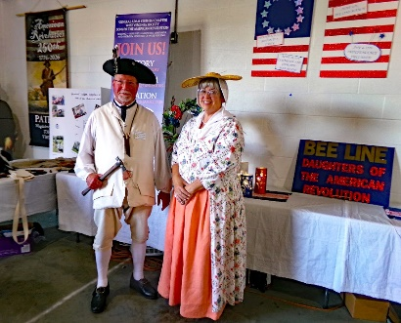
The Sons of the General Adam Stephen Chapter displayed a life-sized standing cutout of George Washington, a popular prop for photo ops, and sold raffle tickets for an American flag. On Friday evening, SAR member Ryan Stottlemyer brought his musket, along with several other artifacts commonly used during the Revolution. Along with his wife Amy, a Bee Line member, he wore period dress and answered questions about life during the Revolutionary era. Together they brough history off the pages of books and into the lives of fairgoers visiting our booth—a worthy demonstration of America 250 as living history.

SAR/DAR husband-and-wife team Ryan and Amy Stottlemyer appear in period attire at our
shared booth during the Jefferson County Fair. They brought along a number of artifacts
representative of the Revolutionary era to provide living history demonstrations for fairgoers.

Bee Line members also played a prominent role as participants in the fair at large. They and their families entered numerous exhibits—from livestock to food preservation and everything in between. Bee Line families took home dozens of ribbons and awards, including Best in Show for Baking, Herbs, and Horticulture.

In addition, members Heidi Ware and Margaret Liskey assisted with Education Day at the fair, giving about 50 special needs students the opportunity to experience fair foods, animals, and rides within an appropriately safe context.

Veteran Moms Baby Shower. Bee Line Daughters continued our tradition of supporting the annual Veteran Moms Baby Shower by providing over $2200 in gifts to this year’s event. Veteran mothers who either give birth or are pregnant during the current calendar year were eligible to participate. Gifts ranged from disposable diapers and wipes, to clothing and baby care products, to infant seats and items of baby furniture. The shower itself consisted of a gathering that featured refreshments, games, and prizes—just like any other shower. Eighteen mothers were feted at the shower itself, and others will receive gifts and support through VA clinics located throughout the Martinsburg catchment area.
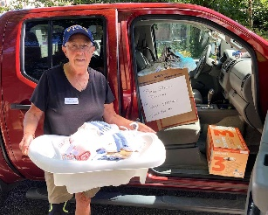
Bee Line Chapter was one of the first organizations outside the VA system to support the annual Veteran Moms Baby Shower—this is true nationally as well as locally. In part because of that history, Darla Treat Courtney, who managed this event for Bee Line, was invited to serve as one of the event’s hostesses.
Daughter Marilyn Bremilst drops off a delivery of gifts for the Veteran Moms Baby Shower

Beyond DAR. Ongoing activities throughout the summer included support for VAMC-Martinsburg, where Bee Line Daughters volunteered at the women’s clothing closet, provided support for the food pantry, donated books for women veterans, and served on the center’s VAVS Committee. And of course, our members also lent their time and talents to numerous organizations within the larger community, including but by no means limited to our local garden clubs, Veterans of Foreign Wars and American Legion posts, local historic societies, the historic homes of Charles Washington and Adam Stephen, and fundraising efforts for the American Cancer Society and the library at Shepherd University.

Catherine Parker Forman
On Saturday, September 13 the Catherine Parker Forman Chapter held its Organizing Meeting at the
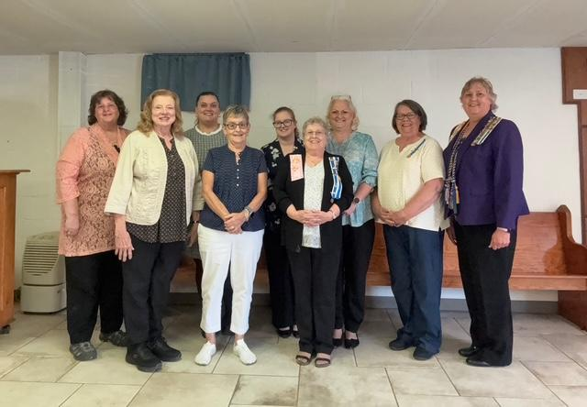
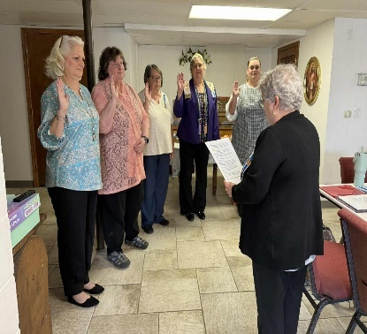
Tearcoat Covenant Brethren Church in Augusta, WV. Oaths of Office were given to Officers and those members in attendance.
Pictured above is Regent Helene Kerns Front row Rebecca Russel, Karina Gray and Helene Kerns;
administering the Oath to her Executive Board back row is Margie Stevens, Olyvia Whiteman, Janelle Mongold,
members. Pam Bane, Susan Sprague and Bonnie Myers

Regent Kerns distributed gift bags to the members present also gave them potted Pansies, to remind them of our State Regent’s theme, Bloom Where You Are Planted.

Highlands of the Potomac Chapter

On June 14, The Highlands of the Potomac DAR chapter honored three Mineral County female veterans. Regent Leeanne King welcomed the guests. Troop 27 led the event with the Pledge of Allegiance. Shelia Dyche, Commemorative chairman explained that June 12, Women Veterans Recognition Day is observed. June 14,1775 the Constitutional Congress established the United States Army. The United States Army is 250 years old today! Linda Coyle chairman, The Flag of the United States, presented US American flags to retired Staff Sergeant Debbie Campbell, and retired Staff Sergeant Liz Logsdon. Bob Shadler of Woodman Life presented a US American Flag to retired Master Sergeant Regan O'Brien. All the veterans had served 20 years or more in the United States Army.
There were 30 guests attending, including eight HOTP members and six US Veterans.
This event at the Carskadon Mansion was followed by a Flag Retirement Ceremony.
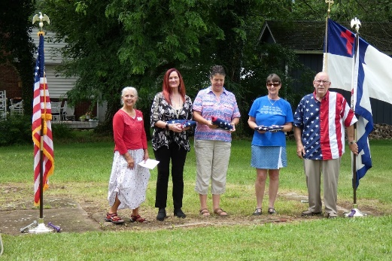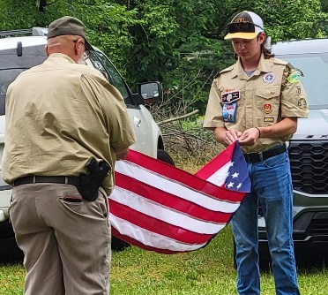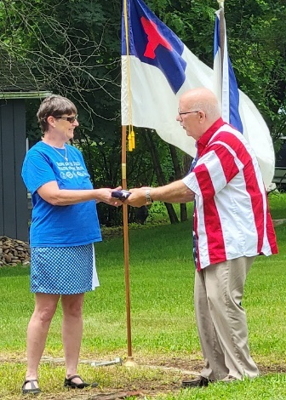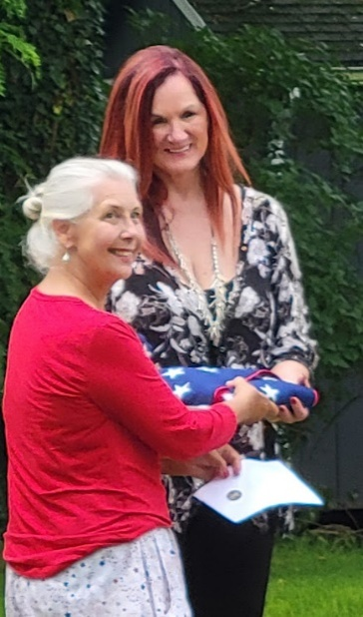

SEPTEMBER 17TH – 23RD
HIGHLANDS OF THE POTOMAC CHAPTER CELEBRATES CONSTITUTION WEEK!
CONSTITUTION WEEK has been a favorite yearly celebration for the members of the Highlands of the Potomac Chapter. Our chapter’s focus this year was to visibly and verbally “Illuminate Our Legacy-Our U.S. Constitution” throughout Mineral County. Our Constitution Committee evaluated previous goals and set a new goal to broaden the chapter’s reach into the county and the high schools! Roadside banners were created and placed along the major highways traversing the county, constitution displays including pocket constitution handouts were placed in three libraries in Mineral County and a storefront on Main Street in Keyser. “U. S. Constitution Minutes” were professionally recorded and featured both live and streaming on our local Mountain Streams Radio 102.9 FM; digital signs throughout the county carried messages about Constitution Week, chapter meetings included reciting the Preamble to the Constitution, patriotic songs and presenting short bios of the signers of the Constitution. Letters went out with our members and to the editor of the Mineral News to invite our churches, organizations and citizens to participate in “Bells Across America” resulting in wide participation on Sept. 17th at 4 p.m. As events occurred, photos and articles were submitted and published in the Mineral News as well as on the chapter and state DAR social media sites. One of the most important new goals for the chapter was to present a program about the U. S. Constitution in both county high schools. HOTP members, some dressing in period attire, are scheduled to present a program to senior class members of both Frankfort High School and Keyser High School. The chapter will present each high school with a Legislative Citation from the WV House of Delegates sponsored by Delegates Gary Howell and Rick Hillenbrand that reads in part: “ The House of Delegates of the West Virginia Legislature hereby recognizes Constitution Week, September 17-23, 2025, honors the Highlands of the Potomac DAR Chapter for their service to the community, and commends the students of Keyser High School and Frankfort High School for their participation in this commemoration of our nation’s founding document.” (No photo as this is scheduled after the submission date 9/20 for the WV DAR Newsletter) HOTP chapter members obtained Constitution Week Proclamations from the Mineral County Commissioners, the Keyser City Council as well as our WV State Delegates Hillenbrand and Howell. In conclusion, and with thanks to our Chapter Regent, Leeanne King, our most impressive achievement was the Proclamation of Constitution Week, September 17-23, 2025 in West Virginia by our WV Governor Patrick Morrisey.
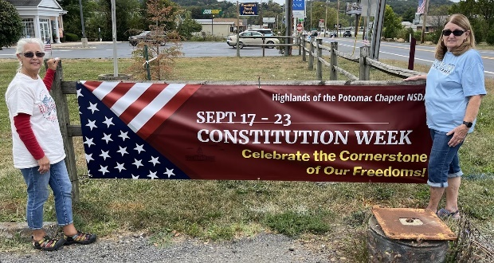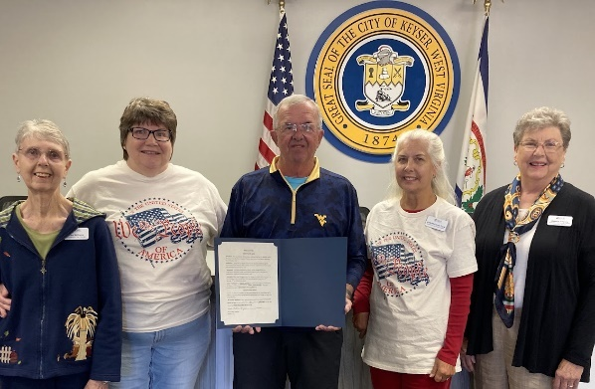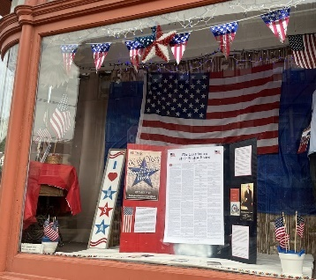

Shenandoah Valley Chapter
What better way to show appreciation to our teachers than with Barby Frankenberry’s infamous Frankenbrittle? For the 2025 Teacher’s Appreciation Week this past May, Shenandoah Valley Chapter NSDAR members Barby McDonald Frankenberry and Margaret Bean Ways delivered 8 batches of
freshly-made “Frankenbrittle” to Musselman High School for the faculty and staff to enjoy. 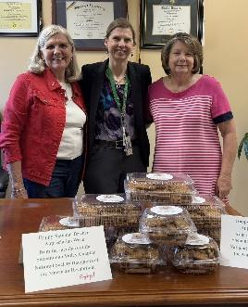 Giving back to our educators
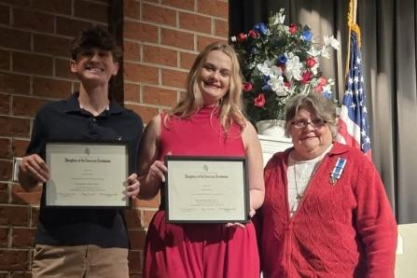
Towards the end of May, Shenandoah Valley Chapter members Barby Frankenberry and Tina Marquart presented the 2025 DAR Good Citizens Awards to deserving seniors Silas Yates and Emily Czaja of Musselman High School, Hunter Tabler and Olivia Morrison of Spring Mills High School, and Noah Brown and Catherine Milliman of Hedgesville High School. We honor these high school seniors who possess and display the qualities of dependability, service, leadership, and patriotism in their homes, schools, and communities.

We celebrate our sparkling youth

Continuing an annual tradition, the Shenandoah Valley Chapter hosted its 20th Anniversary of the
“Thank You Veterans Dinner!” on June 3, 2025. While the dinner was catered, chapter members filled
the dessert table with many homemade goodies. Entertainment was provided by The Blue and Grey Chorus, an all- time favorite. A highlight of the evening is when they sing the theme songs of each service
branch, and veterans of each stand with the singing of their song.
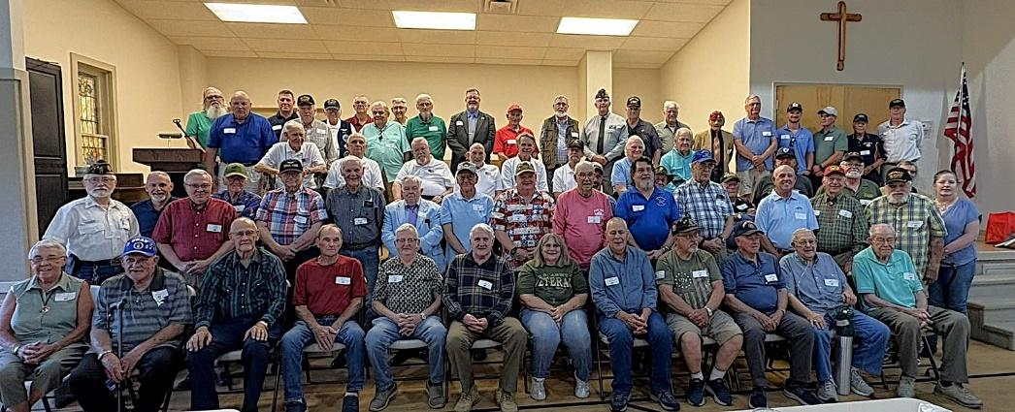
We honor our veterans
On June 7, 2025, the West Virginia Daughters of the American Revolution dedicated a DAR America 250 Patriots Marker at Morgan’s Grove Park in Shepherdstown to honor the 250th anniversary of the Bee Line March of 1775. Taking part in the ceremony were Shenandoah Valley Chapter members Margaret “Margie” Ways as the Eastern District Director and Barby Frankenberry as a descendant of a Bee Line March patriot.
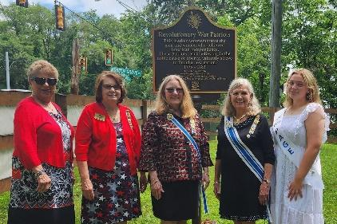Preserving history and promoting patriotism
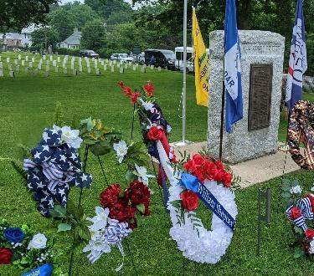
Continuing with the Bee Line March celebrations on June 14, 2025, members of the Shenandoah Valley Chapter participated in a wreath laying ceremony at the Bee Line Memorial Marker in Elmwood Cemetery, Shepherdstown, WV. Conducted by the Pack Horse Ford Chapter, participants included several WV DAR chapters, the Gen. Adam Stephens NSSAR color guard, various lineage society chapters, and descendants of the Bee Line March. Shenandoah Valley Chapter members laying wreaths were Barbie Frankenberry - chapter treasurer and descendant of Bee Line March participant [then] 1st Lt. William Henshaw; Deanna Kay – chapter historian who lay a wreath for the Shenandoah Valley Chapter; and Sally Ann Greenfield - vice-regent, who lay a wreath for the Capt. James Gibson Chapter, National Society United States Daughters of 1812.
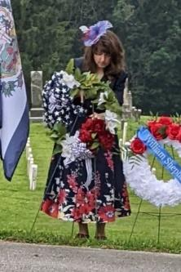

August is the time for the WV Eastern District meeting. At the August 16, 2025 meeting in Keyser, WV, the Shenandoah Valley Chapter won numerous WVDAR State and East Central certificates, awards, and a National “Glimmer” award for our Good Citizenship program.
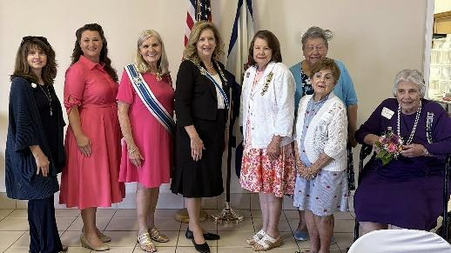

Kicking off this year’s Constitution Week, Shenandoah Valley Chapter members met with the Berkeley County Council on September 11, 2025, for them to sign a Proclamation declaring September 17, 2025, as Constitution Day. On Constitution Day itself, the chapter members rang bells at 4pm on the steps of the Berkeley County Courthouse.
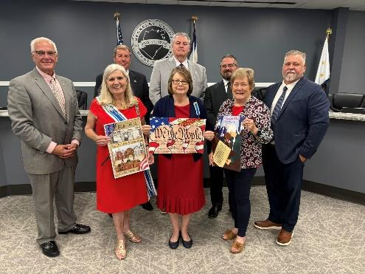

William Henshaw Chapter
NSDAR SPARKLES AT AUGUST EVENT
Three members of the William Henshaw Chapter, NSDAR, attended the recent 78th Annual meeting of the Eastern District West Virginia State Society, DAR on Saturday, August 26, 2025 in Keyser, WV. Former Regent, Julia Gates, Registrar Joanne Krishack and New Regent, Deborah E, Hammond, attended the
meeting to represent the chapter. The morning devotions were led by Regent, Deborah E. Hammond. Old
business focused on the Eastern District America 250 Project and the participation by each of the Eastern Panhandle chapters in preparing a brochure on the Revolutionary War patriots from each chapter. The State Regent message focused on the three initiatives of the Sandra Isner-Johnson administration which include Education, Patriotism and Historic Preservation. A presentation was featured by historian Jim Hoey on Virginia and the Backcountry Rebellion. At the time of the Revolutionary War, the area that now encompasses the State of West Virginia, was all part of the State of Virginia.
The William Henshaw Chapter was awarded thirteen awards by the East Central Division. These included the Discover Treasured Gems Award from the Membership Committee, Outstanding Service as a State Chair Award to Julia Gates from the Service to America Committee, Outstanding Support to the
Military from the DAR Project Patriot Committee to Julia Gates, Outstanding Service as Chapter Registrar Award from the Lineage Research Committee to Registrar, Joanne Krishack, Outstanding Support to the Military Award to Joanne Krishack from the DAR Project Patriot Committee, Third Place for Donations of
Magazine Subscriptions to Other Organizations from the DAR Magazine Committee, Outstanding Support to the Military to the Chapter from the DAR Project Patriot Committee, Outstanding Support to the Military to Shelley Hamilton by the DAR Project Patriot Committee, Outstanding Support to the
Military to Jackie Richards from the DAR Project Patriot Committee, Outstanding Support to the Military to Laura Shifflett from the DAR Project Patriot Committee, Outstanding Support to the Military to Eileen Southerly from the DAR Project Patriot Committee, Blue Ribbon Award for Chapter Achievement from the Master Reports Committee for the Chapter as a whole, Outstanding Use of Technology to
Deborah Hammond from the Volunteer Information Specialist Committee, Outstanding Support to the Military award from the DAR Project Patriot Committee to Deborah Hammond. Congratulations to all of the William Henshaw Chapter Members awarded certificates at this year’s meeting and to the chapter as a whole for the 2025 accomplishments. Work begins on the 2025-2026 year at the September 6, 2025 meeting. The William Henshaw Chapter meets generally once a month on the first Saturday of each month, between the months of September and June. For more information on joining the William Henshaw Chapter, please contact Chapter Registrar, Joanne Krishack at joanne.krishack@comcast.net.
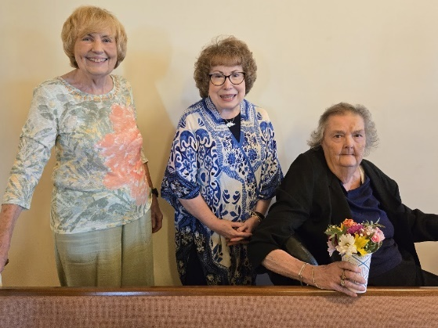Joanne Krishack, Deborah E. Hammond and Julia Gates

Northern District Director
Anne Royall Chapter hosted the Northern District WVDAR annual meeting at the
Women’s Club-Lions Club Community Center in Harrisville, WV on August 23, 2025.
Julia Hoffman, District Director, introduced our 2025-2028 District Officers Annetta
Siers District Treasurer and Anna Carson District Secretary. Also welcomed were our
State Regent Sandra Isner-Johnson, along with other Chapter Regents, State officers
and committee members.
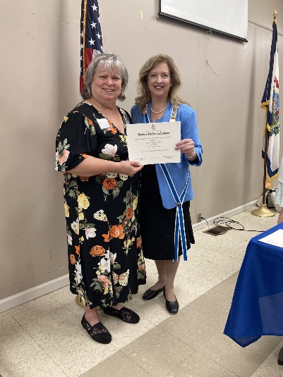
Gloria Batten, Regent of the Jonathan Sheppard Chapter in
Elizabeth, and chapter members were welcomed to their first Northern District Meeting.

The ladies were entertained by Mr. Steve Ritter, Ritchie County commissioner, who performed a variety of our favorite oldies, followed by a delicious lunch provided by the Crossroads Café of Pennsboro.
The new financial policy as outlined in the NSDAR Guide for Chapter and State Treasurers was explained in a presentation by Stella Moon, Southern District Director. Annetta Siers and Linda Snider presented a lovely memorial service honoring those Daughters that we lost this past year. The hard work of the Northern District Daughters was highlighted by the National and State Awards that were presented by State Regent Sandra Isner-Johnson.
Mrs. Shannon Sams Harper invited all to attend the 2026 Northern District meeting that will be hosted by the Blennerhassett Chapter.

Blennerhassett Chapter
Blennerhassett Daughters attended three Lafayette events in May, which included Gallipolis, Ohio, Marietta, Ohio, and Wheeling.
At the AFJRROTC Awards Banquet in May, then Regent, Cathy Hinkle, presented the JROTC bronze medal, certificate, and monetary gift to award recipient Julia Acklin.
For Memorial Day, then Regent, Cathy Hinkle, placed a wreath at the Riverside Cemetery in Williamstown. Incoming Regent, Shannon Sams-Harper, took the opportunity after the ceremony to place a flag on a recently deceased Marine’s grave. After the ceremony, Taylor Sams presented a flag for disposal during a ceremony at the American Legion in Williamstown.
A community service opportunity in June saw our chapter providing lunch for volunteers at the Habitat for Humanity ReStore in Vienna, and the employees of the Wood County Parole Officers in Parkersburg.
Significant flooding occurred in June, and our chapter collected items to support the victims of the flooding in our community.
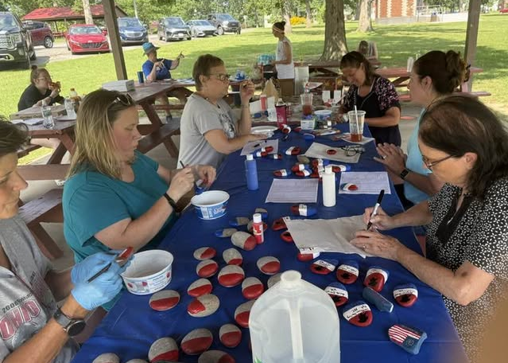
Of course, Blennerhassett Daughters are busy planning for America 250 events. In July we met at Parkersburg City Park to work on our painted rock project. Peg Foley painted the base colors on our rocks, and chapter members wrote the names of Patriots represented by our chapter members on the rocks. These rocks will be placed in our community to promote America 250 and to honor our Patriots. Regent Shannon Sams-Harper also invited everyone to walk around the park with her in support of women’s health and fitness.
We supported our veterans in July by donating basic school supplies to stuff the backpacks for local veteran families.
August was a busy month for the Blennerhassett Chapter! We met at Panera Bread where an instructor taught us how to sign the Pledge of Allegiance and also provided a very handy handout.
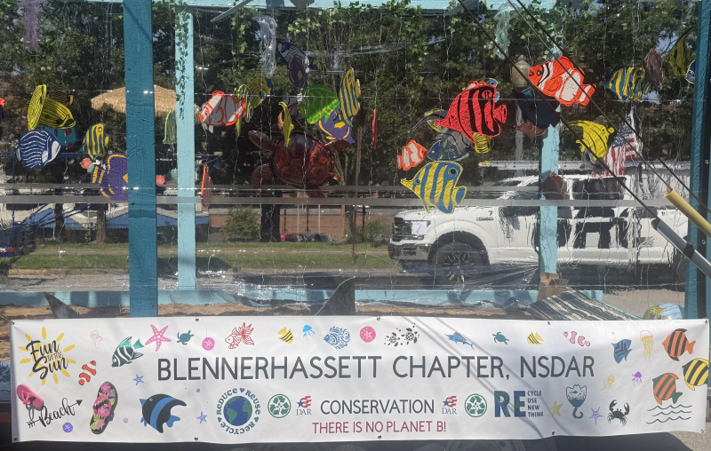
The Parkersburg Homecoming is also in August, and this year the theme for the parade was “Fun in the Sun.” Who doesn’t love fun in the sun at the beach? Our chapter’s conservation themed float portrayed the beauty of the ocean and the importance of being good stewards of our environment. Our float was a saltwater aquarium! Mary Pfeifer cut tropical fish out of plywood and chapter members helped paint the fish. We also included shark fins, jellyfish and a huge sea turtle. We tossed conservation themed silicone bracelets, Swedish fish, and inflatable globe beach balls to participants. We won first place in our division!
The day of the homecoming parade was also National Honey Bee Day and we emphasized the importance of honey bees and their role in our ecosystem, particularly in pollination and food production. Chris Painter and Mary Pfeifer made a bee hive that trailed behind our float in the parade, and Bit o Honey candy and bee themed silicone bracelets were given to parade goers.
If we don’t preserve and protect our natural resources, ensuring a sustainable future for generations to come, there will be no fun in the sun because there is no planet B!
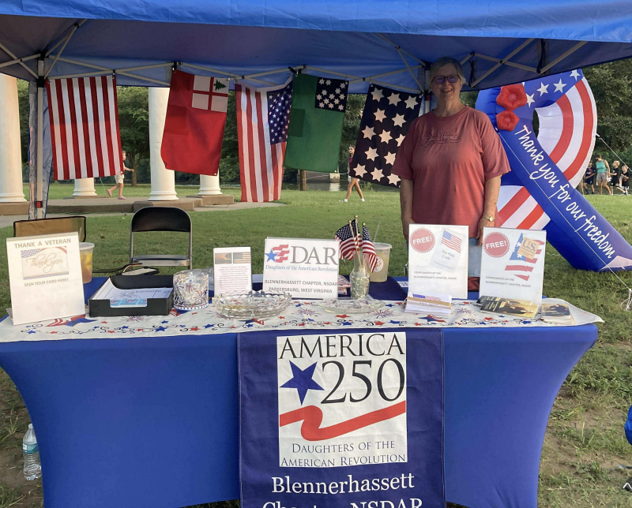
Our chapter also hosted a booth during homecoming weekend. Melody Zimmerman created replicas of our country’s early flags which were displayed around our booth. She also provided a handout that described each of the flags. Regent Shannon Sams-Harper took the lead in teaching children the Pledge of Allegiance where certificates and a goodie bag were provided to 70 children. We also distributed pocket Constitution booklets, flag codes, lapel pins, and coloring sheets with crayons, and provided an opportunity for people to sign thank you cards for our veterans.
We met again at city park in August to work on another project for American 250. Melody Zimmerman prepared all of the materials to make “church dolls” that will be distributed during a chapter event next year, and everyone worked together to assemble the dolls.
Our chapter promoted Constitution Week by having two displays at local libraries offering pocket Constitution booklets and book marks, and Williamstown displayed a Constitution Week message on their digital sign.

James Wood Chapter

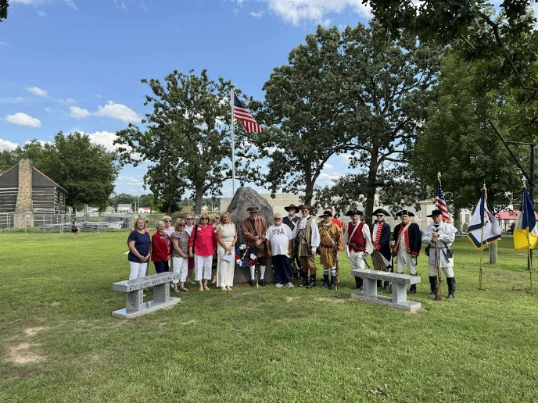
James Wood members and Captain James Neal SAR
at Parkersburg City Park, August 3, 2025 for
America 250 Projects Dedication.

James Wood Chapter WVNSDAR met August 3rd with Captain James Neal Sons of the American Revolution at Parkersburg City Park to dedicate their America 250 Projects. Through grants and generous
donations from James Wood Daughters we were able to purchase a granite bench bearing the names of thirteen additional patriots buried in Wood County that were discovered while doing the research for
“Genealogical, Burial and Service Data for Revolutionary War Patriots Buried in West Virginia”. We were also able to purchase an illuminated flagpole to showcase the area. The flag was donated by Congressman Brad Winstrep of Ohio. The Captain James Neal SAR purchased an identical granite bench
through grants and donations by members. The original marker placed in the park in 1908 bearing the names of Revolutionary War Patriots was cleaned and restored to its original beauty by an SAR member.
The ceremony concluded with a musket salute.

Jonathan Sheppard Chapter
The Jonathan Sheppard Chapter had a busy summer! In June we had a table at RiverFest in Elizabeth where we gave out flags for Flag Day and asked people to sign cards for patients at the Louis A. Johnson VA Medical Center. It was also the Army’s birthday and we met several veterans who had great stories to share. We had a nice time until the thunderstorm where we got a “little wet”!
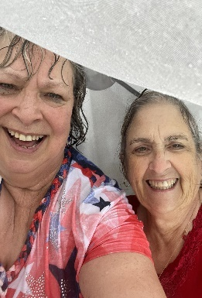
Gloria Batten and Kay Hill

Chapter member Barbara Corbitt learned of a need for fans at the VA Center and our chapter collected 24 fans which Barbara delivered to the center along with the cards collected from RiverFest.
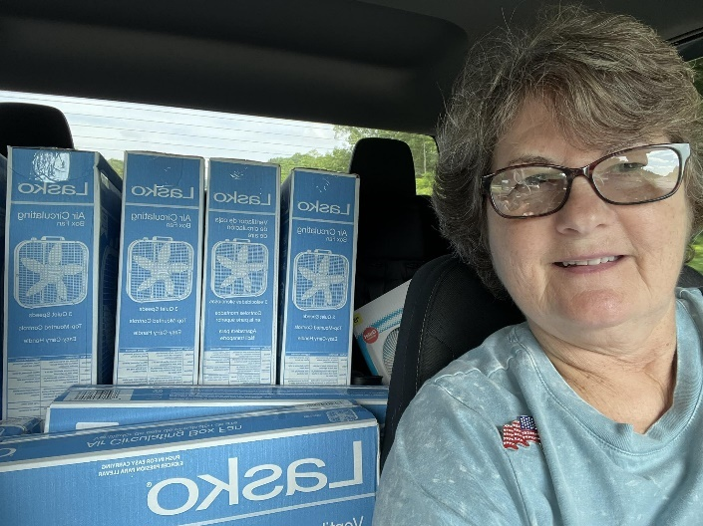
Barbara Corbitt
In July we participated in the annual Fireman’s Parade in Elizabeth. We also donated goodies to the Elizabeth Wirt Volunteer Fire Department for their Ice Cream Social following the parade.
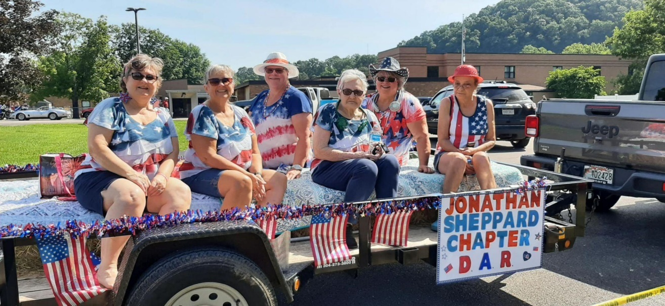
Members Barbara Corbett, Kay Hill, Brenda Cooper, Naomi Lockhart, Gloria Batten and Virginia Clark.

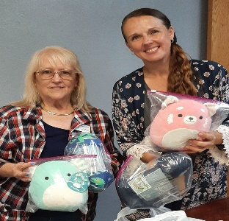
Member Shirley McCoy and Sheriff’s office secretary
August found us welcoming two new members to our chapter! We were also busy creating an informational display about DAR for the Wirt County Fair, donating greeting cards to a local nursing home for the residents, donating items to the Sheriff’s Office to give to children during stressful situations, helping a new teacher in our county with classroom supplies, and cleaning headstones in preparation for a church homecoming.

Ohio Valley Chapter
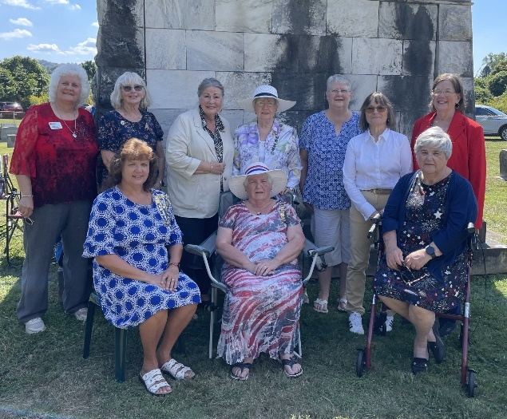
The Ohio Valley Chapter Daughters of the American Revolution held a book dedication on September 13, 2025 at the Long Reach Cemetery, Long Reach, WV at 1:00 pm with 30 in attendance. The history book is being used as a fund raiser for the restoration and continued care of the Long Reach Cemetery.
The Ohio Valley Chapter genealogy team worked closely with the Long Reach Cemetery Association making sure all the facts were researched and documented. Gene Bell and Kenny Holmes provided the old stories and old pictures to be used. Descendants of the old families brought stories, journals, old Bible records and old newspaper clippings. Gene collected all of these, wrote his memories of growing up at Bens Run and made a map of the area to be used as a reference.
The book spans the time from the ancient Adena and Hopewell Indians who built the walls and the mounds that once was a very large village. to 1955 when the land was sold to the Lindi Air chemical plant. During the Revolutionary War era the land was given as land grants. The old Red Mud Church was used during the Civil War as an encampment which would be behind the ancient walls. Sad to think that 15 young men died and are buried in an unmarked graveyard across from the old church. During the oil boom it is noted that there were over 50 families living at Long Reach (mostly oil field workers and their families). The village of Long Reach was a booming little village with 2 General Stores, a Post Office, a Millinery Shop, a Blacksmith Shop, a Steamboat Factory, a Stave and Barrel Factory, a Grist Mill, a depot, a sawmill, a Creamery and Confectionary Shop, 2 churches, a school and a Fire Department with a bell tower on top. In the 1930- 40’s there was air mail when a plane would drop the incoming mail and pick up the outgoing mail without having to land. There was also a small airport at Bens Run that was used in the 1940’s.
We hope you will enjoy this book and support the Long Reach Cemetery.
A Sincere thanks to the Ohio Valley Chapter members and the Genealogy Team (Anna Carson, Frannie Weekley, Lee Eddy, Blye Grove, Linda Poynter and Kathy Eckert) and Patsy Adkins, WV DAR Genealogist. Also to all the community donors Gene Bell, Kenny Holmes, Frank Slider, Jim Grove, Cliff Eddy, Dana Dearth, Elizabeth Miller, and Paul Frum. A special Thank You to Andy Weekley, Fire Chief of the Sistersville Fire Department for directing traffic at the cemetery.

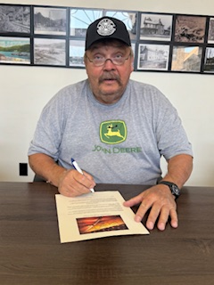
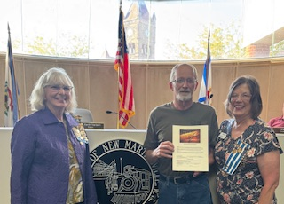

Local officials sign Proclamations for Constitution Week 2025. They are Sistersville, William Rice; Steven Thomas, Friendly; Clerk from Paden City, Dave Myers, Middlebourne; and Keith Nelsen from New Martinsville. From Pleasants County, the Pleasant County Commissioners, Jay Powell, Mike Smith and Doug Renner; Mayor of Belmont , Tim Barnes and St Mary's Pat Boyles.

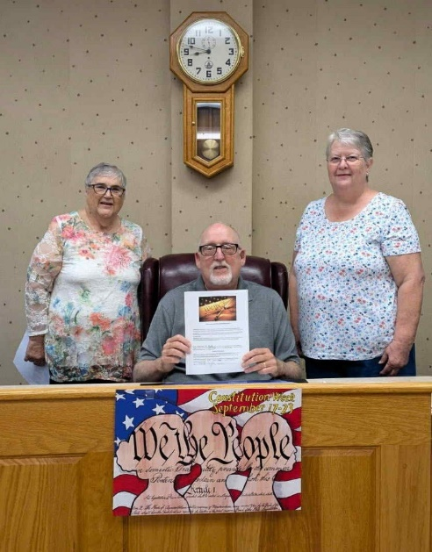

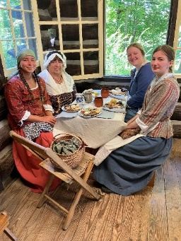
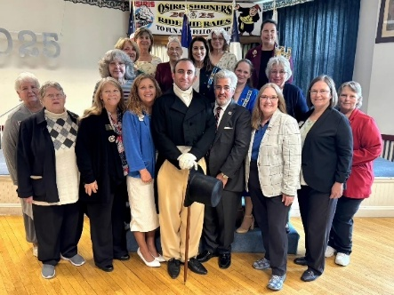
Wheeling Chapter
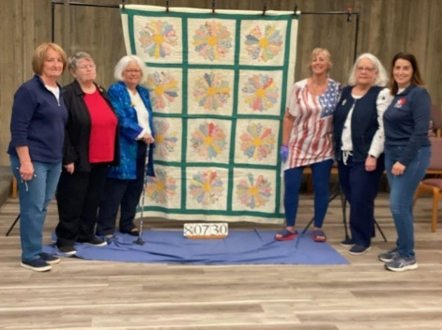
DAR members WITH General Lafayette Wheeling members at Quilt Documentation Ladies at Fort Henry tea

Southern District Director
Stella Moon,
District Director
304.482.7685
southerndistrictwvdar@hotmail.com

The Southern District’s 80th Annual Hybrid Meeting, hosted by the Matthew French Chapter, was held on July 12 at the First Baptist Church in Princeton. This was the first hybrid district meeting with eight (8) individuals attending via Zoom.
On behalf of the Southern District, Stella Moon, district director, welcomed WVDAR State Regent Sandra Isner-Johnson, to her first district meeting. The State Regent shared her administration’s theme, “Bloom Where You Are Planted,” her scripture verse, and her proposed state projects. She announced that the 2026 State Conference will be held at The Greenbrier, with the Southern District serving as host.
Then she presented NSDAR East Central Division and WVDAR State certificates to Southern District chapters and members, recognizing them for their service to DAR.
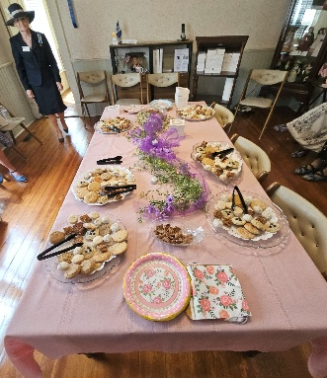
Tea at the McNutt House

State officers and chairs in attendance shared announcements regarding their respective positions.
Samantha Shleser, immediate past district director; Nancy Kornegay, immediate past district secretary; and Deborah Phillips, immediate past district treasurer; were recognized for their service to the Southern District by Stella Moon, Southern District director.
The Southern District was the first to pass the Financial Policy for Subordinate Organizations and the Authorized Signatories for its checking account.
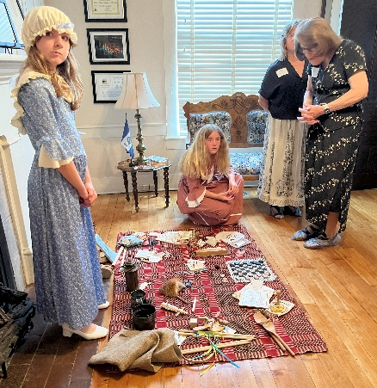
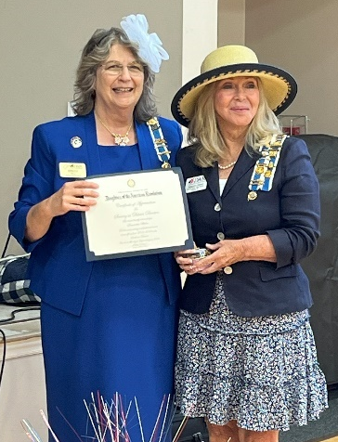

Samantha Shleser recognized for Junie Wood and Olivia Morgan demonstrate
her service to the Southern District children’s toys and games of the colonial era.

The Southern District will host a Registrar’s Workshop on Saturday, October 18. How to Host a Hybrid Meeting Workshop will be offered later in the year.
Barbara McDowell, Matthew French Chapter’s Chaplain, led the Memorial Service remembering departed daughters Brenda Hawks and Helen Garner, Captain James Allen Chapter; Ann Brody, General Andrew Lewis Chapter; Roberta Kniffin, Matthew French Chapter; and Mary Robertson, Peters Mountain Chapter.
The DAR-ling Auction proceeds of $544 were designated for the 2026 State Conference expenses. The district donated $100 to the proposed State Regent’s projects.
The 81st Annual Southern District meeting will be hosted by the Peters Mountain Chapter.
Immediately following the business meeting, the Matthew French Chapter hosted a tour and tea at the Dr. Robert B. McNutt House, the only remaining house in Princeton that survived the Civil War. A tour of the house was provided by chapter members in period dress. The chapter’s office is housed in this historical home.

Captain James Allen Chapter

Captain James Allen Chapter Attends Lilly Family Reunion

Flat Top, WV

Written By: Jocelyn R. Woods
On Saturday, July 19, 2025, the Captain James Allen Chapter of the Daughters of the American Revolution (DAR), from Beckley proudly participated in the Lilly Family Reunion. This annual event was filled with engaging activities and meaningful connections that highlight our shared history and values. One of the highlights of the day was Terry Noland’s interactive “Spin the Wheel” game. Children enthusiastically spun the wheel and answered questions related to the Revolutionary War, the history of West Virginia, and the significance of the U.S. Flag. This fun educational activity not only entertained the young attendees but also instilled a sense of pride in our nation’s heritage. In addition to the game, the chapter distributed various educational materials and keepsakes, including U.S. Flags, information on the Flag Code, copies of the U.S. Constitution, The Pledge of Allegiance, and the Americans Creed.
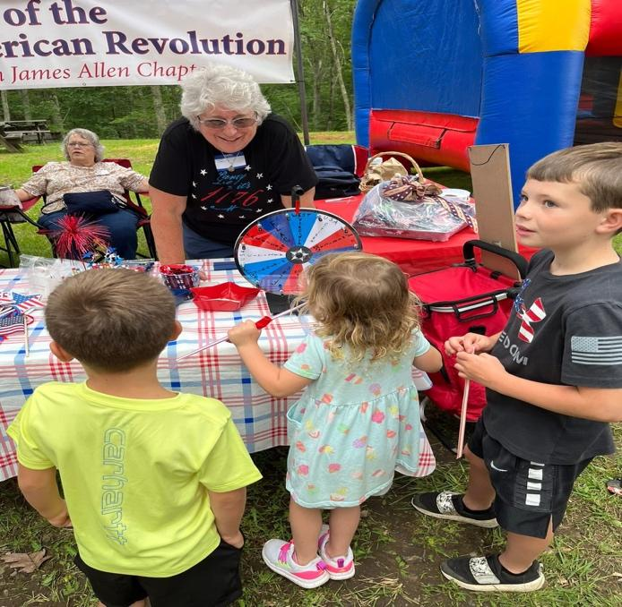
During the reunion, we had the pleasure of meeting Patricia Sherman Lilly, whose husband, JK Lilly, is a member of the Beckley Sons of the American Revolution (SAR). Patricia shared her family’s inspiring story. Her grandparents immigrated from Italy to the United States in the early 1900s, showcasing the rich tapestry of American heritage. Although Patrica is not eligible for DAR membership, her accomplishments are noteworthy. She won the DAR 8th grade History Essay contest in 1967, which was sponsored by a DAR chapter in Williamson, West Virginia. Her passion for history and storytelling resonates with the values we uphold as members of DAR.
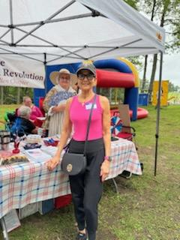

Patricia Sherman Lilly Patricia Sherman Lilly

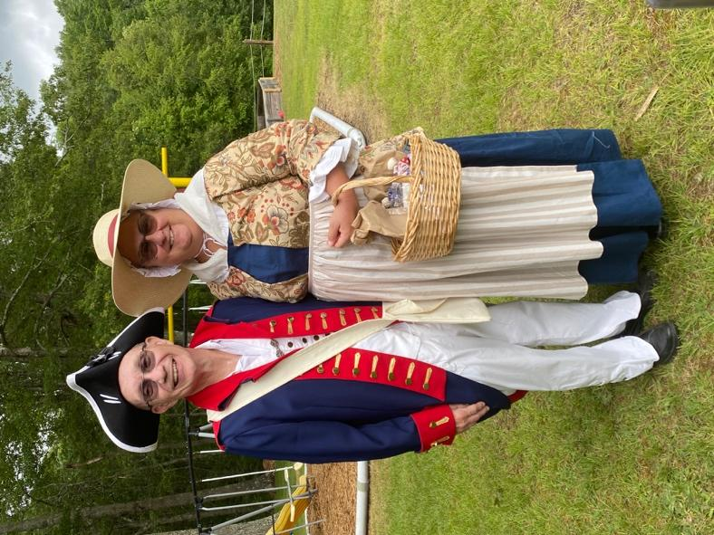
Doug Bonifacio, member of the Beckley SAR,
& Jennifer Goodwin, DAR Captain James Allen Chapter

The Lilly Family Reunion provided a wonderful opportunity for the Captain James Allen Chapter to engage with the community, share our mission, and foster connections with individuals like Patricia Lilly. We look forward to participating in more events that celebrate our history, and the values of patriotism, education, and community service.

Constitution Week Celebrations
During Constitution Week, the Captain James Allen Chapter of the Daughters of the American Revolution (DAR) engaged students across local schools in meaningful activities to celebrate our nation's foundational document.
Cherri Farley visited Coal City Elementary in Raleigh County, reading to a total of 60 students. Her interactive storytelling captivated the young audience and fostered a deeper understanding of the Constitution.
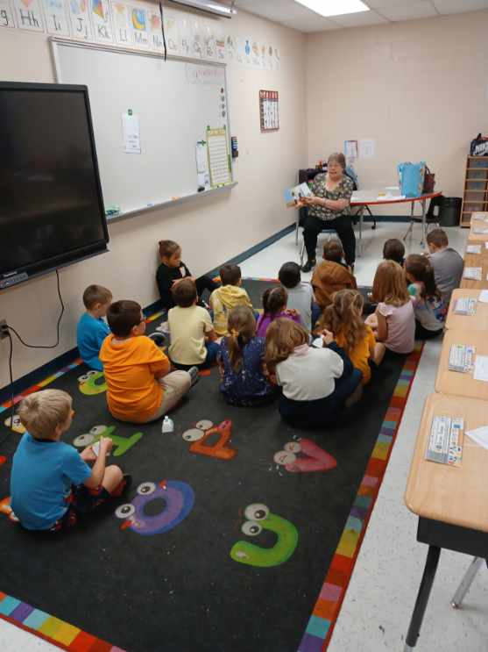
At Lewisburg Elementary in Greenbrier County, Ginger Lilly not only read to the students but also distributed handouts to help them create their own Constitution booklets. This hands-on approach encouraged creativity and personal connection to the Constitution.
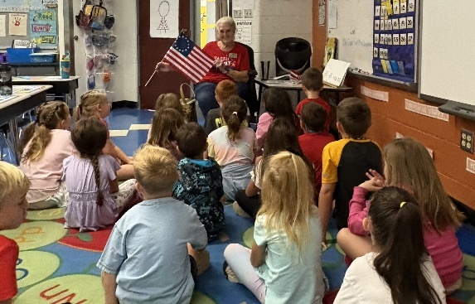
Nikie Mitchell and Terry Noland brought the celebration to Daniels Elementary, also in Raleigh County, on September 9th. They engaged 82 first-grade students through interactive readings, where students participated by holding pictures of historical figures and places mentioned in the stories. To further enrich the experience, coloring pages depicting people from 1787 were provided for teachers to distribute. As a special touch, students received bells to ring at 4:00 PM on Constitution Day, marking the occasion with enthusiasm.
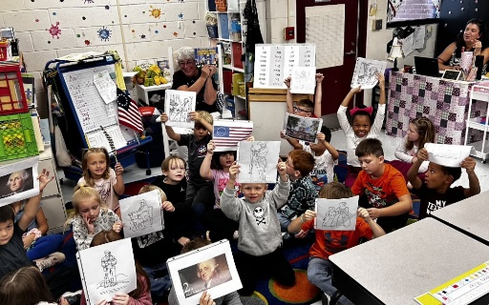
Amy Choate and Nikie Mitchell recently visited Shady Spring Elementary School, where they read to three first-grade classes, reaching a total of 64 students. Their engaging storytelling helped the young learners connect with the principles of the Constitution.
Following their time at the elementary school, Amy and Nikie moved to Shady Spring Middle School, where they hosted an exciting game of Jeopardy with a sixth-grade class. The quiz challenged students on their knowledge of the Constitution, making learning both fun and interactive.
These activities not only educated students about our nation's foundational document but also fostered a sense of civic engagement among the youth.
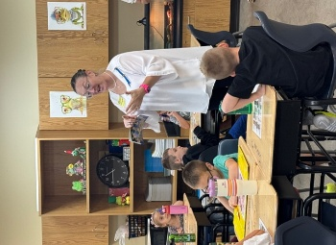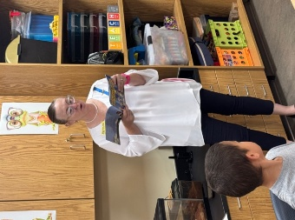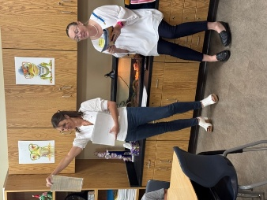
Linda Sumner and Linda Whitman set up an informative display at the Raleigh County Public Library to celebrate Constitution Week. Throughout the week, the display highlighted the importance of the Constitution and its relevance today.
As a special contribution, they will be donating a copy of the Constitution to the children's library, ensuring that young readers have access to this vital document and can learn about its significance.
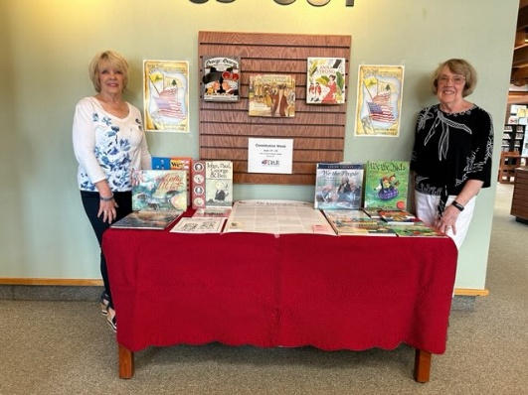
Ryan Neal, the Mayor of Beckley, signed a Constitution Week proclamation in honor of the occasion. This important proclamation was prominently displayed at the Raleigh County Public Library, emphasizing the significance of the week in our community.
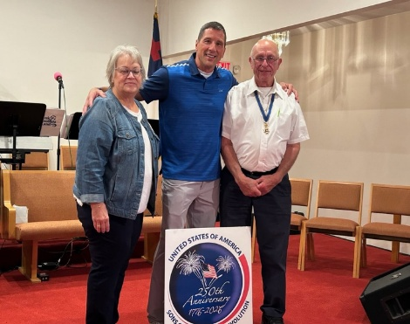
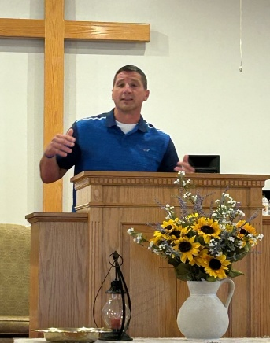
Wreath Laying Ceremony at the 250th Anniversary of the Beeline March
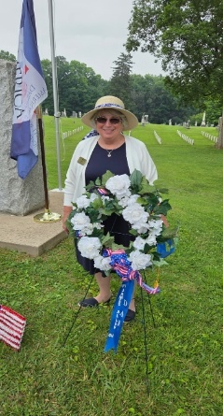
On June 14th, Terry Noland proudly represented the Captain James Allen Chapter of the Daughters of the American Revolution (DAR) at a wreath laying ceremony commemorating the 250th anniversary of the Beeline March in Shepherdstown. This significant event celebrated our rich history and honored the sacrifices made during this pivotal moment. Terry's participation highlighted the chapter's commitment to preserving and promoting our nation's heritage.

General Andrew Lewis Chapter
The Greenbrier County Commission adopted a proclamation designating the week of September 17 is constitution week in Greenbrier County. Present for the event were representatives of the General Andrew Lewis Chapter Daughters of the American Revolution.
Pictured from left to right- Commissioner Ritchie Holliday, Chapter Parliamentary - Jodie Nidey,
Regent Deborah Phillips and Commission President Lowell Rose.
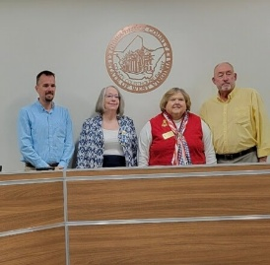

The chapter is also participating in the Committee’s planning the West Virginia DAR state conference. For more information contact -Debbie Phillips Regent, General Andrew Lewis Chapter,304-545-3956

Matthew French Chapter
For Memorial Day, Matthew French daughters placed flags on graves of departed daughters and veterans.

Flag Day was celebrated by thirty-two youth at the Wade Center in Bluefield. The youth learned about the history and symbolism of the flag, the Pledge of Allegiance, and the Star-Spangled Banner. Members of the local Mercer County American Legion Post 54 taught the students the correct way to fold a flag. The youth completed an eagle wind spinner craft. A Trivia Quiz was a fun way for them to show what they learned. Congratulations to Heather Farley, chapter treasurer, and the American Legion for teaching the history and care of the flag. The youth and staff received flags, pencils, and flag decals. Patriotic cookies were enjoyed by the students.
The chapter presented The Wade Center with a new flag as the American Legion retired their old flag.
Then the members visited Mary’s Cradle, a maternity and infant community outreach center. They donated books, toys, educational games, infant and toddler clothing, bibs and blankets, bottles and pacifiers, diapers and wipes, personal care items, booster chair, table high chair, umbrella stroller, and funds to purchase a crib, mattress, and sheets. To wrap up a successful DAR Day, the members enjoyed a luncheon at the Fincastle Country Club.
At the Chapter’s June meeting, Samantha Shleser, Southern District Director, installed the 2025-2028 chapter officers. They are Stella Moon, regent; Michelle Sparks, vice-regent and registrar; Barbara McDowell, chaplain; Mary Shaw Van, recording secretary; and Heather Farley, treasurer. A memorial service was held for departed daughter Roberta Kniffen Woodson.

Members Karen Seguin-Barton and Stella Moon attended Continental Congress. Associate members attending were Peggy Orbea, Margie Sentelle, and Leah White.

On July 12, the chapter hosted the Southern District’s annual meeting. The chapter received the following National Awards: 1) Master Reports Committee – Chapter Achievement Awards Blue Ribbon; 2) American History Committee – Outstanding Community Events on History with Children; 3) DAR Magazine Committee – East Central Division – WTC Articles, 1st Place; 4) Children of the American Revolution – East Central Division – Outstanding Chapter Support; 4) DAR Leadership Training Committee – East Central Division – Twinkling Stars Award. National awards awarded to individuals were: 1) Karen Seguin Barton, DAR Museum Outreach Committee, East Central Division – Outstanding Correspondent Docent 2024; 2) Karen Seguin Barton, DAR Museum Outreach Committee, East Central Division – Special Recognition by Receiving her Correspondent Docent Pin and 3) Michelle Sparks, Lineage Research Committee, East Central Division – Outstanding Service as Chapter Registrar.
State Awards received were First Place for the chapter’s Digital Scrapbook and the Press Book.

Members attending and assisting with the district meeting were: Heather Bostic, Nell Bowman, Nicole Bowman, Donna Brewster, Heather Farley, Jo Anna Fredeking, Debbie Gillespie, Sharon Houston, Barbara McDowell, Stella Moon, Opal Morgan, Mary Shaw Van, Michelle Sparks, Barbara Wood, and Louise Witt. Mary Low Brown and associate member Cynthia Masterson attended via Zoom. Cynthia hosted the hybrid meeting on behalf of the chapter. Also, in attendance were Olivia Morgan and Juniper Wood, Margaret McKensey Society CAR. Jim Wood and Greg Morgan, General Hugh Mercer Chapter SAR assisted Juniper and Olivia with posting and retiring the colors.

The chapter welcomed three new members – Lisa Bradford, Stephanie Oberempt, and Robaleen Woodson – in July. Members watched a video entitled, Dr. Joseph Warren: Celebrating the Legacy of America’s Founding Martyr, to support the National CAR project.

An Installation Ceremony was held for Betty Lykins and Janice Moon Barrera, who are cousins, at the Christie Reunion. Ozella McKenzie Christie is Betty’s grandmother and Janice’s great-great-grandmother. A third cousin, Robaleen Woodson, will be installed in September. Robaleen’s McKenzie relative was a sibling of Mrs. Christie.

In September, the Chapter held a work party to prepare for Constitution Week activities. Educational materials were placed in packets for the first and fourth grade students in Mercer County Public Schools. There are 536 first grade students in 33 classes and 581 fourth grade students in 31 classes. First graders received a flag coloring sheet, pencil, and flag. A Constitution Week Activity Booklet and pencil were given to fourth graders. Church dolls, buzz saws, bags of marbles, and bells were prepared for Bells Across America.

The first and fourth grade teachers receive digital files about two patriots, Matthew French and General Hugh Mercer, that highlight their contributions to our country.

Nell and Nicole Bowman prepared a Constitution Week poster displayed at the Princeton Public Library. In October, the City of Princeton will present a Constitution Week Proclamation to the chapter.

On September 17, the Matthew French Chapter, the General Hugh Mercer Chapter SAR and the Margaret McKensey Society CAR hosted Bells Across America Mercer and Straley Elementary Schools’ 150 fourth graders and 9 teachers. Students participated in outdoor demonstrations for making a cloth doll, shooting marbles, playing with a buzz saw (whirligig), and learning what life was like for soldiers and citizens during the colonial era. They were excited to receive a bell, a buzz saw, marbles (boys) and a doll (girls).

Students toured the 1840s home of Dr. Robert B. McNutt, a prominent physician and business man. Dr. Shellie Simpson, Mercer School principal, wrote, “Thank you so much for having us yesterday. We had a great time. We are currently reading Little House on the Prairie as our One School One Book selection and watching episode selections for social and emotional lessons. Seeing this in real life further enhances their learning experience while also teaching them about our local history. We always love this trip.”

WVVA-TV highlighted our Constitution Week and Bells Across America’s events, “Students step back in time for Constitution Day at McNutt House.” Stella Moon, chapter regent; Juniper Wood, Margaret McKensey Society CAR; and a fourth-grade student were interviewed.

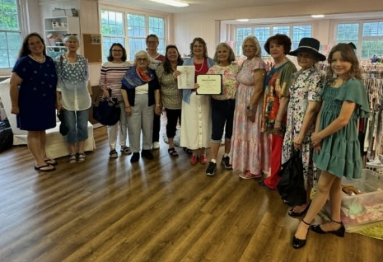
Members at Mary’s Cradle

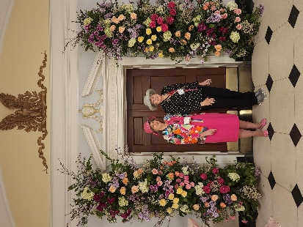
Stella Moon and Margie Sentelle at Continental Congress.

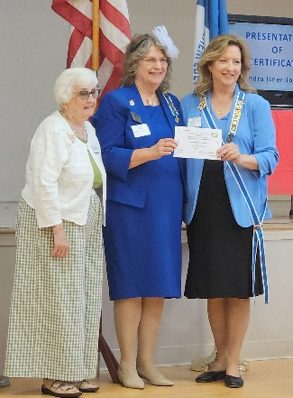
JoAnna Fredeking and Stella Moon accept Press Book, Small Chapter, 1st Place Award from State Regent Sandra Isner-Johnson.

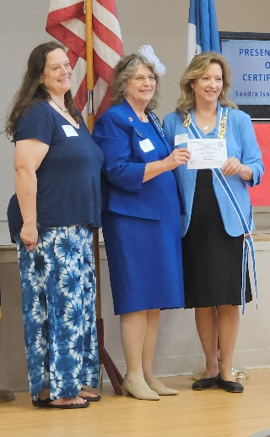
Heather Farley and Stella Moon accept Press Book, Small Chapter, 1st Place Award from State Regent Sandra Isner-Johnson.

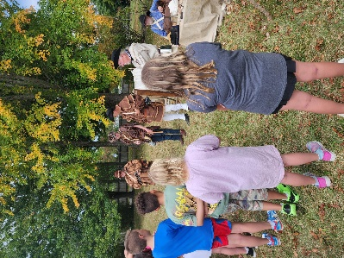

Bells Across America at the Dr. Robert B. McNutt House

Colonel Charles Lewis Chapter
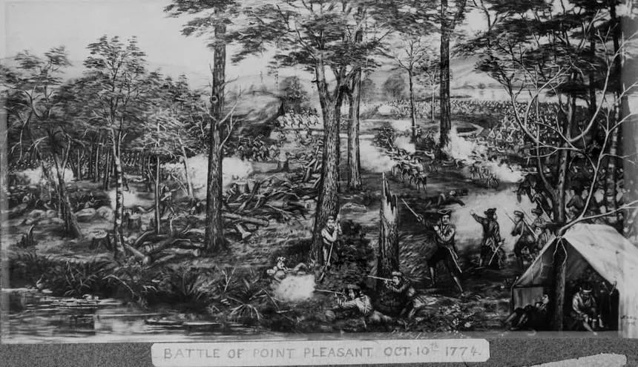

The Point Pleasant Chapter of the WVSSAR cordially invites you to the 251st anniversary commemoration of the Battle of Point Pleasant on October 3rd, 4th and 5th, 2025.
Activities:
Friday, October 3rd, 2025 - Education day
Beginning at 8:00am, demonstrations at Tu Endi Wei State Park of colonial life and Revolutionary War regimental and militia activities for various school groups and visitors.
Lantern tour of various stations and reenactors at dusk by the DAR.
Saturday, October 4th, 2025
10:30 am - Muster of all SAR Color Guard personnel at 10th and Main Street, Point Pleasant, WV.
11:00 am - The SAR Color Guard leads the Battle Days Parade beginning at 10th and Main Street and ending at the Tu Endi Wei monument for group pictures.
06:00 pm - The Colonial Governors Reception will begin at the Main Street Baptist Church, 11th Ave and Main. St., Point Pleasant, WV. (Pre-registration required for all SAR attendees and guest).
08:00 pm - The Colonial Governors Ball will begin at the Main Street Baptist Church, 11th Ave. And Main St.., Point Pleasant, WV (Open to all.) 18th century attire encouraged but not required. No charge, but registration encouraged.
______________________________________________________________

Sunday, October 5th, 2025 - 10:00 am - Early Colonial church service at Tu Endi Wei State Park.
11:30 am - Colonial Brunch will be offered at Randolph Terrace, 305 Main Street*, Point Pleasant, WV. (Pre-registration required)
*immediately adjacent to Tu Endi Wei State park for convenient parking.
1:00 pm - Commemoration service and wreath presentation honoring the fallen at the Battle of Point Pleasant. (Pre-registration required).
______________________________________________________________
Area lodging:
Hampton Inn
(740) 446 8000
444 State Route 7 South
Gallipolis, Ohio 45631

Super 8 Motel
(740) 446 8080
321 Upper River Road
Gallipolis, Ohio 45631

4 Seasons Inn
151 Upper River Rd.
Gallipolis, Ohio 45631

Old Hickory Chapter
The Old Hickory Chapter enjoyed several events together this summer. Not only did we attend our usual events like Continental Congress, the Independence Day parade, and the Western District meeting, but we also celebrated Flag Day and WV Day, and honored Korean War Veterans. There was even the opening of a long-term project by our Regent. Two events occurred on the same day on June 14th. The first was waving flags for Flag Day at the Ripley City Hall building. We even displayed our new banner for the 250th Anniversary of American Independence. The second was a flag retirement ceremony, hosted by The Point Pleasant Chapter SAR, Colonel Charles Lewis DAR, and Fort Randolph CAR at Tu-Endie-Wei State Park.
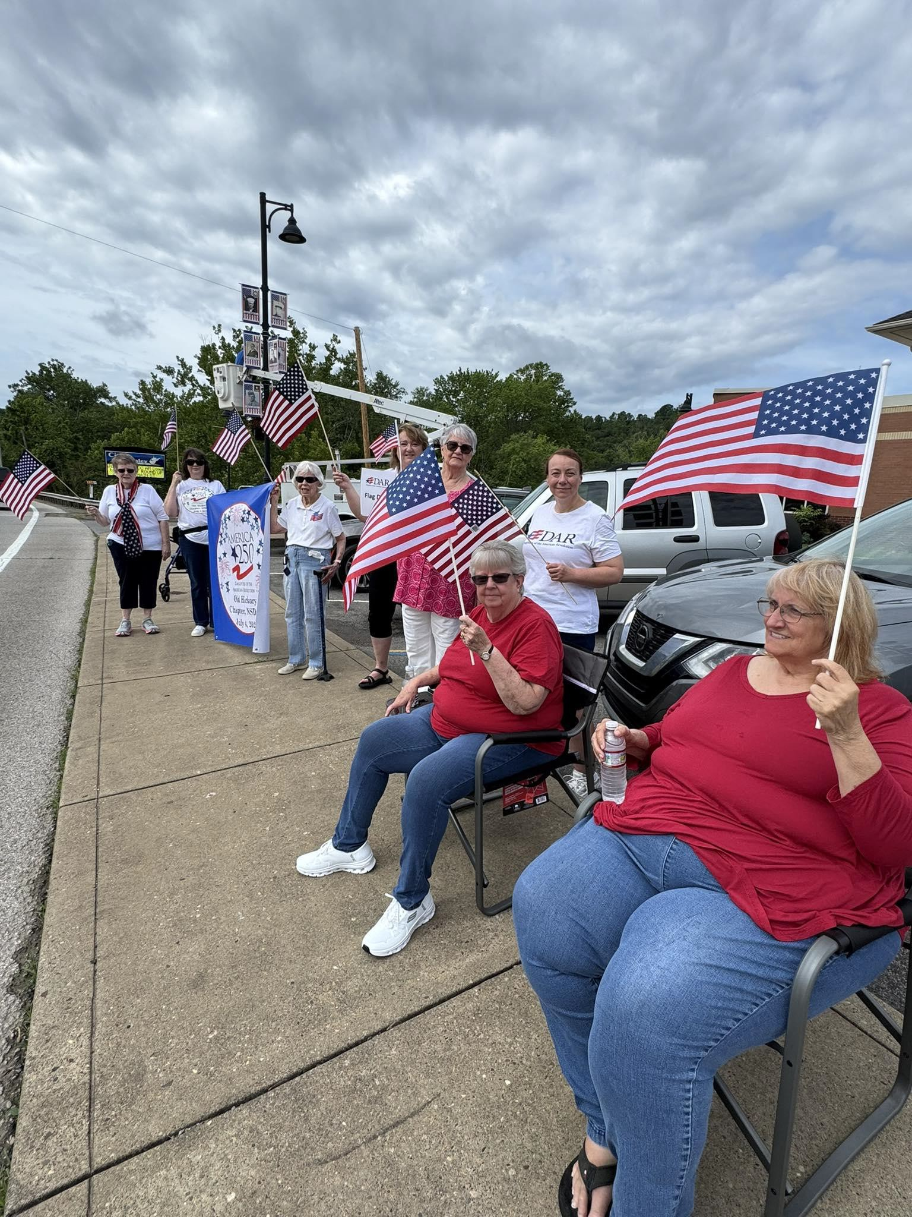
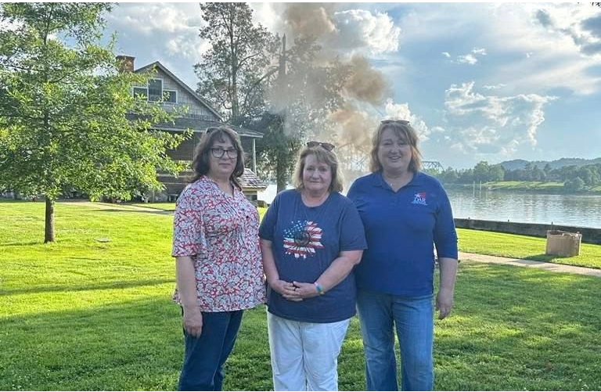
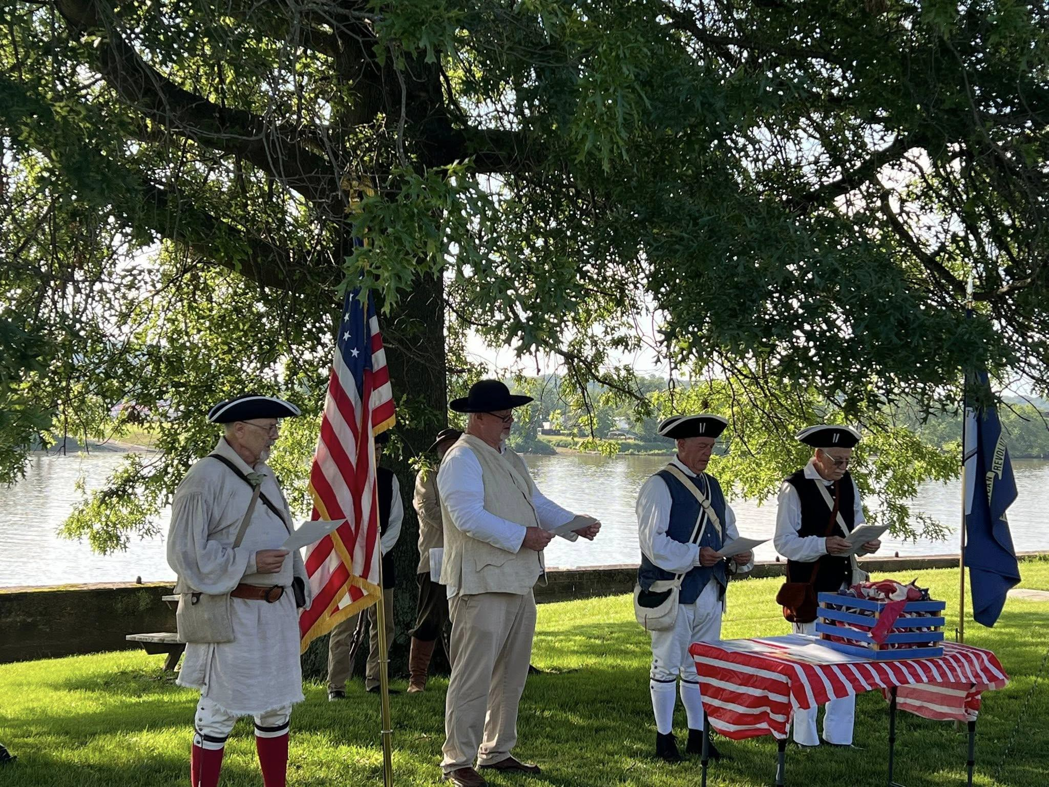
For WV Day on June 20th, the Mayor of Ripley asked the chapter to help in the celebration on the courthouse lawn. Members dressed in Colonial Attire and helped serve refreshments for the big day.

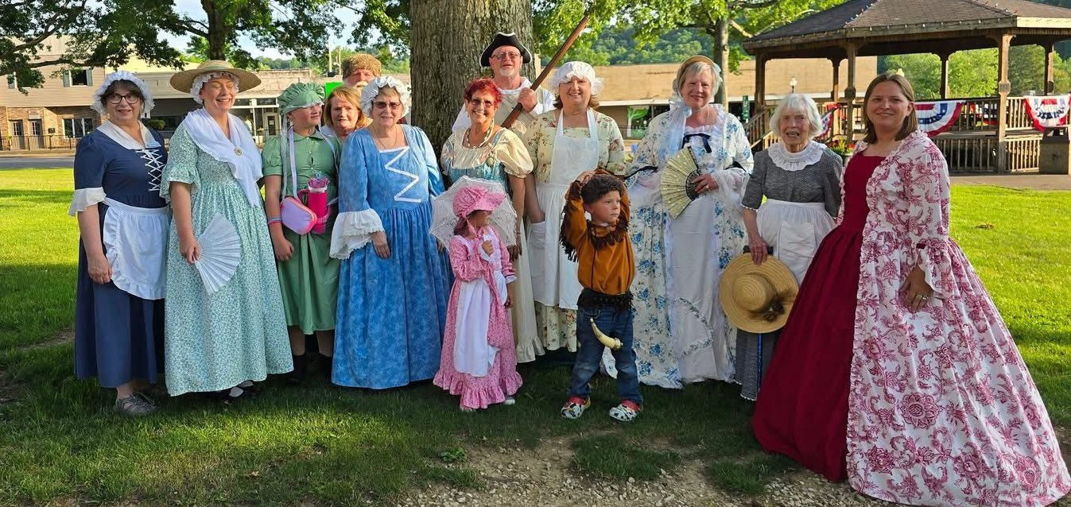

At Continental Congress this year, Old Hickory had the honor of seeing their Regent, Grace Arthur, awarded by President General Pamela Wright. She was awarded the WV Outstanding Junior title and is now the National Vice Chair of the Junior Membership Committee.
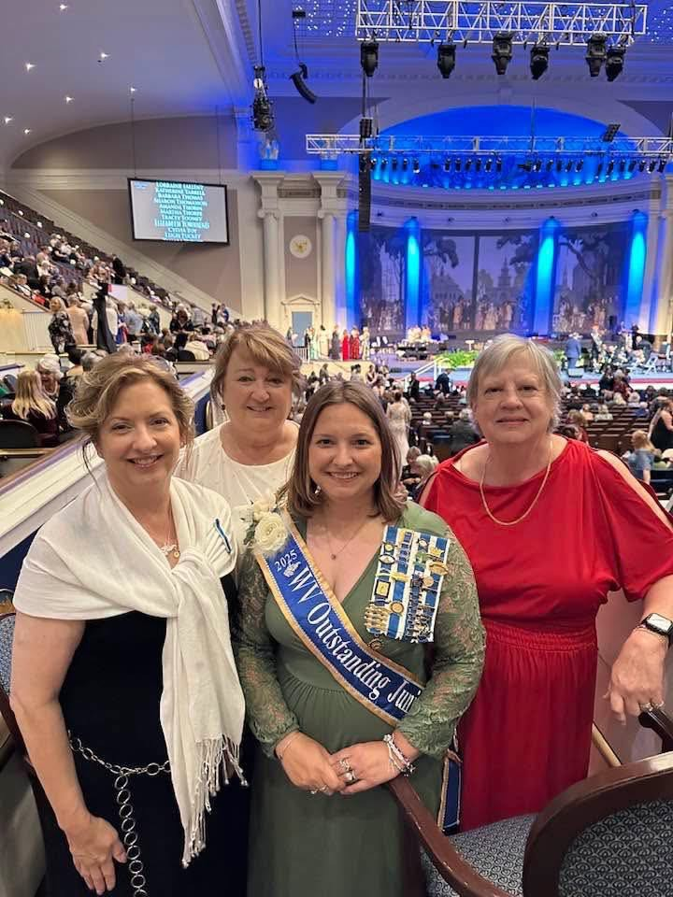
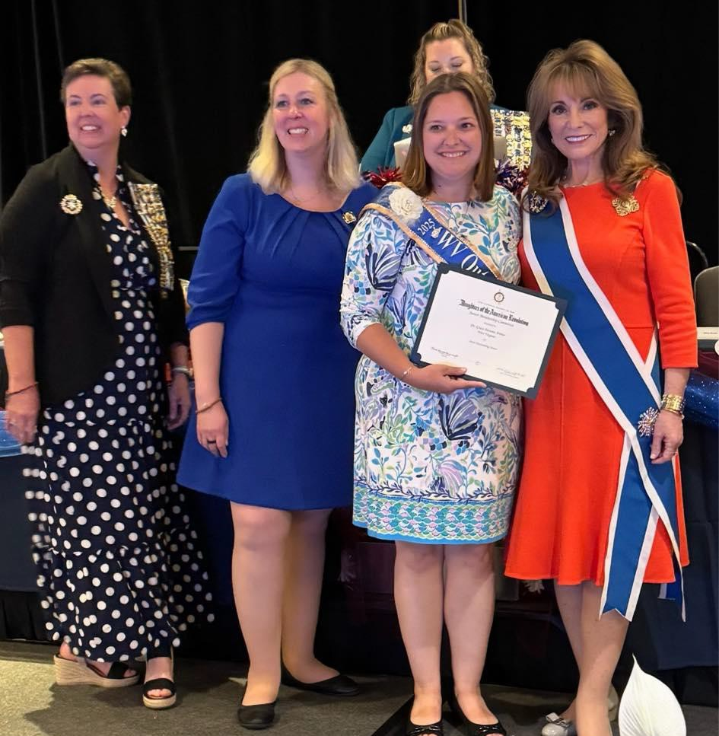

Independence Day was celebrated on a float in Ripley’s Largest Small Town July 4th Parade. While passing out candy, we also spread the word about the upcoming 250th Anniversary of American Independence in 2026, with a new banner proudly displayed.
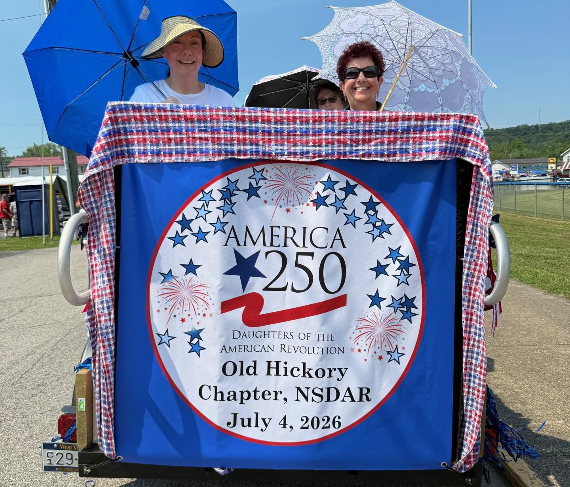
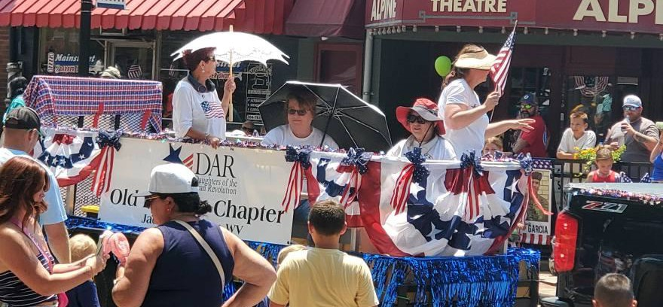

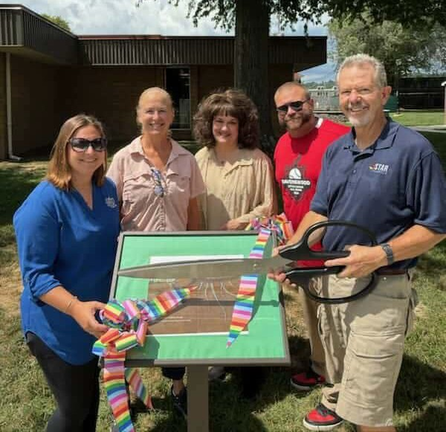
The Story Walk ribbon cutting in Ravenswood was held on July 14th. The Story walk is a set of 14 pedestals that hold pages of a story. It is located at Ravenswood City Park and is used to promote literacy in the area. Our Regent, Grace Arthrur, headed this project. The library is assisting by adding new stories each month.

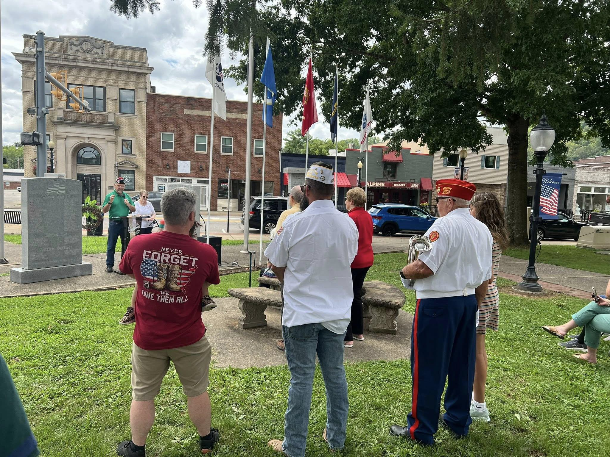
On August 2nd, Mary Pistelli held a ceremony honoring Korean War Veterans. As our chair for DAR Service for Veterans, Mary works hard to honor all of our veterans with ceremonies through out the year.
The Western District meeting was held on August 9th. We had several attendees this year and many awards won by our chapter members.

At our Dues Tea meeting on September 6th, we held new officer installations and new member installations. We also collected school supplies for a local class. Officer inductions were done by Brenda Cheuvront. The installed officers were: Selma Humphreys- Regent, Debbie Burge- Vice Regent, JoAnn Jones- Chaplain, Amy Conrad- Recording Secretary, Megan Wray- Corresponding Secretary, Joann Clarkson- Treasurer, Heather Harrison- Registrar, and Mary Pistelli- Librarian. Those not pictured are: Terry Barley- Historian, and Joanna McKown- Parliamentarian. New member installations were done by Chaplain JoAnn Jones and Registrar Heather Harrison. New members installed were: Amy Conrad, Beth Keller, and Courtney Buskirk.
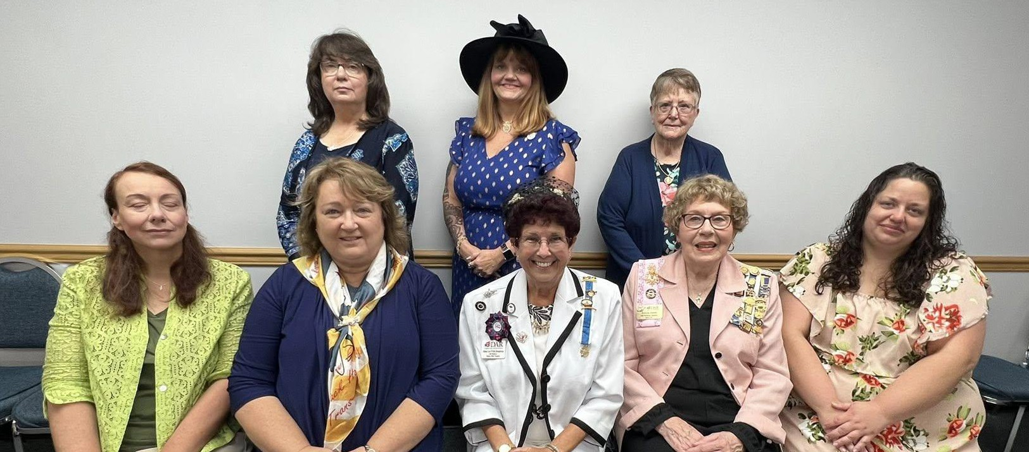

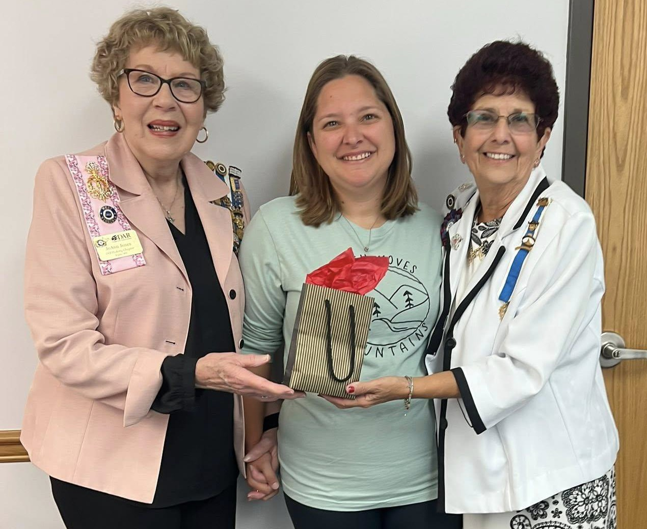
Grace Arthur was appointed as Honorary Regent and received her Past Regent pin, presented by Chaplain JoAnn Jones and Regent Selma Humphreys.

Westmoreland Chapter
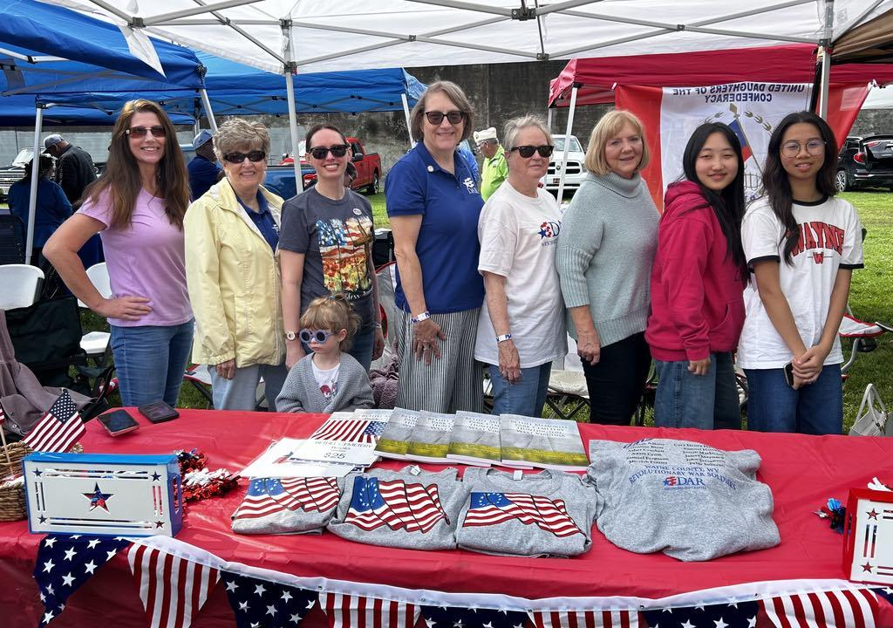
Deanna Muncy, Deborah Hoback, Tera Merritt, Audrey Merritt, Stephanie Smith, Sheila P.
Stevenson, Linda LeMaster, Chloe Kwon, and Putter Svetnaya proudly pose to commemorate the day.
Military and Veteran Appreciation Picnic
Westmoreland Chapter DAR daughters of Ceredo, West Virginia spent Saturday May 31st serving delicious BBQ to veterans, military personnel and their families at the 14th annual Military and Veteran Appreciation Picnic at Harris Riverfront Park in Huntington, WV. Over 1000 people were provided a free and delicious meal including ice cream and watermelon. The crowd enjoyed oldies music played by a local band. Canons boomed on the hour as a local Sons of the Confederacy chapter loaded and lit their cannon. Numerous community service vendors also attended to offer services to members.
Organizer Ron Wroblewski spends months every year planning the event to honor veterans and military personnel. Westmoreland Chapter Regent Stephanie Smith honored Wroblewski at the event to honor his achievement of being chosen the national NSDAR Veteran Volunteer of the Year recipient. Veterans present expressed their gratitude to Smith and the Chapter for honoring Wroblewski’s achievement.

Rules for Newsletter
- The Regent, State Committee Chair or Directors only will submit articles. If you are a chapter committee chair your article must be submitted by the Chapter Regent.
- Articles should be no longer than 200 words.
- Articles should be for the preceding three months. If it happened 6 months ago it is not news.
- Deadlines must be strictly adhered to
A. Deadline for January issue: January 5
B. Deadline for April issue: March 25
C. Deadline for July issue: June 25
D. Deadline for September issue: August 25
- Two pictures per article.
- If it has a deadline or submission date, send to VIS Chair.
- Decide if the information is for the State Information Packet (SIP) or the newsletter.

I am trying to make this interesting and informative and share information. Old information and deadlines that have passed before publication do not help anyone.

I apologize for this issue. My computer “died” (a slow and painful death). I know that we will improve with each issue. Just be patient with me.

Order your America 250 Insulated Tumbler
to support the Proposed WVV State Regent’s Project

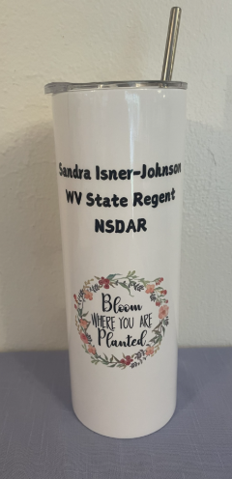
Front Back
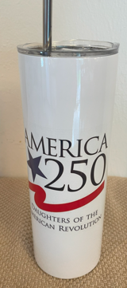
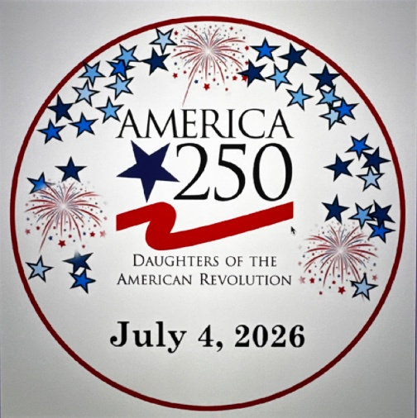
Actual Logo Actual Logo

Tumblers are $25.00 each $ include cover, straw, and straw cleaning brush

Front Side displays the America 250 logo
Back Side displays State Regent’s Theme

Back Side Optional – Your Name, Chapter or Title (Additional $5.00)
-------------------------------------------------------------------------------------------
Name:________________________________________________
Address: __________________________________________________
Phone Number:_______________________________________
Chapter Name:_____________________________________________
Optional Back (Please Specify):___________________________
Front and Back (only $25.00) Back Optional (additional $5.00)
Please make checks payable to: WVDAR
mail to: Selma Humphreys, 131 Batton Drive, Ripley WV 25271

